|  |
| --- |
|  |

Ministry of Health

Up-skilling Project



Supervised by:

Dr. Jalal Kiswani

Dr.William Smairat

Ms. Jacquelyn Brown

Ms. Hana Al-Rasheed

# Acknowledgements

After thanking God for everything, I would like to thank Hussein Technical University for giving me this great opportunity to develop my knowledge of programming, soft skills and English language that I never had. I would like to thank Dr. Jalal Kiswani, Dr.William Smairat, Ms. Jacquelyn Brown, and Ms. Hana Al-Rasheed for supporting and helping me all this time.

# Abstract

I wanted my website to be simple, and uncomplicated with colors that are suitable and comfortable.

This website is programmed in PHP Work as backend programmer and the frontend is designed with HTML5, CSS3, JavaScript and Bootstrap framework.



# Table of content

1. **Acknowledgements-------------------------------------------------------------------------------------------------1**
2. **Abstract----------------------------------------------------------------------------------------------------------------2**
3. **Intruduction ---------------------------------------------------------------------------------------------------------4**
4. **Project Details ------------------------------------------------------------------------------------------------- 5**
   1. **Technology ---------------------------------------------------------------------------------------- --5**
      1. **Front-End ---------------------------------------------------------------------------------- 5**
      2. **Back-End ---------------------------------------------------------------------------------- 5**
      3. **Modeling -----------------------------------------------------------------------------------5**
      4. **Version Control --------------------------------------------------------------------------5**
   2. **Requirments ----------------------------------------------------------------------------------------------6**

**4.3 Design -------------------------------------------------------------------------------------------------------7**

**2.3.1 SiteMap ----------------------------------------------------------------------------------------7**

**2.3.2 Wireframe -------------------------------------------------------------------------------------8**

**2.3.3 Mockup ----------------------------------------------------------------------------------------17**

**2.3.4 Prototype -------------------------------------------------------------------------------------26**

* + 1. **ERD ----------------------------------------------------------------------------------------36**

**4.4 Development ---------------------------------------------------------------------------------------------37**

**4.5 Testing -----------------------------------------------------------------------------------------------------38**

* + 1. **Test Cases --------------------------------------------------------------------------------38**

**4.6 Deployment ------------------------------------------------------------------------------------------------39**

**2.6.1 Domain ----------------------------------------------------------------------------------39**

* + 1. **Hosting -------------------------------------------------------------------------------39**

1. **SourceCode Excerpts ------------------------------------------------------------------------------------------40**
2. **Conclusion ---------------------------------------------------------------------------------------------------------42**
3. **References----------------------------------------------------------------------------------------------------------42**

# List of figures

Figure 1 Technology 5

Figure 2 Site Map 7

Figure 3 Wireframe (Homepage). 8

Figure 4 Wireframe (Achievement). 9

Figure 5 Wireframe (Ministry). 10

Figure 6 Wireframe (Strategy). 11

Figure 7 Wireframe (Contact). 12

Figure 8 Wireframe (Announcement). 13

Figure 9 Wireframe (Form). 14

Figure 10 Wireframe (Interactive Map). 15

Figure 11 Wireframe (Patient). 16

Figure 12 Mockup (Homepage). 17

Figure 13 Mockup (Achievement). 18

Figure 14 Mockup (Ministry). 19

Figure 15 Mockup (Strategy). 20

Figure 16 Mockup (Patient). 21

Figure 17 Mockup (Announcement). 22

Figure 18 Mockup (Form). 23

Figure 19 Mockup (Interactive Map). 24

Figure 20 Mockup (Rule). 25

Figure 21 Prototype (Health). 26

Figure 22 Prototype (Rule). 27

Figure 23 Prototype (Homepage). 28

Figure 24 Prototype (Minister). 29

Figure 25 Prototype (Achievement). 30

Figure 26 Prototype (Project). 31

Figure 27 Prototype (Contact). 32

Figure 28 Prototype (Vaccines). 33

Figure 29 Prototype (Interactive Map). 34

Figure 30 Prototype (Patient). 35

Figure 31 ERD. 36

Figure 32 Test Cases. 38

# Introduction

The foundation of success in life is good health: that is the substratum fortune; it is also the basis of happiness. A person cannot accumulate a fortune very well when he is sick.

I chose the Ministry of Health because it is considered the most important ministry at the present time due to the corona pandemic. We all have to care about our health and read everything about it (articles, advice...) because the human is our most precious possession.

My website contains many tips, information about many diseases, news, announcements, and many electronic services that citizens need: Ideal Weight, Suggestions or Complaints and Vaccinations for Babies.

I created my website to be easy to use, simple, able to open from any device (mobile/laptop), responsive, can be translated into different multiple languages, and the colors are suitable and comfortable.

# Project Details

### Technology

### 1. Front End

Front-end developers work on what the user can see. which are:

(HTML5 CSS3, JavaScript and Bootstrap framework).

### 2. Back End

Back-end developers build the infrastructure that supports it.

(PHP)

### Figure 1 Technology

### 3. Modeling

Sitemap (XMind).

Wireframes and Mockups (Adobe XD).

Entity Relationship Diagram ERD (lucidchart.com).

### Version Control

Github.

# Requirements

## The User Requirements Specification describes the business needs for what users require from the system. The user requirements used in this website:

## The user should be able to use the Website easily.

## The user should be able to navigate through the pages.

## The user should be able to open the website from a mobile (responsive).

## The user should be able to download AMAN application easily provided in the Website header.

## The user should be able to send suggestions and complaint.

## The user should be able to know when their baby should receive vaccines.

## The user should be able to know their ideal weight.

## The user should be able to translate it into different multiple languages.

# Design

## Site Map

## Site maps used during the planning of a Website and organized lists or flow chart diagrams that shows connections between web pages, web page trees, and website content.

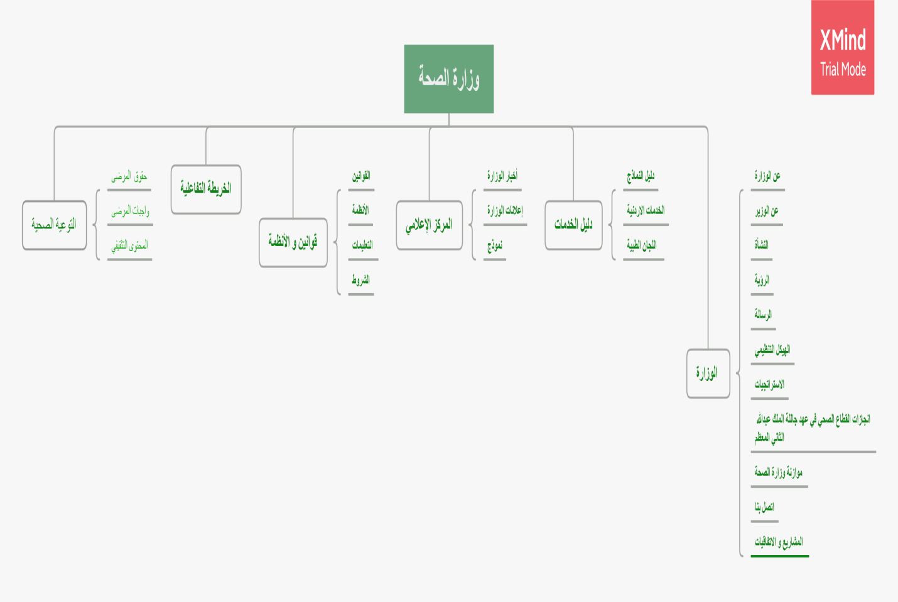

### Figure 2 Site Map

## Wireframes

* A wireframe is equivalent to simple structure of your website. The decisions on what (content/features) and where to put on the website are usually made during this stage.

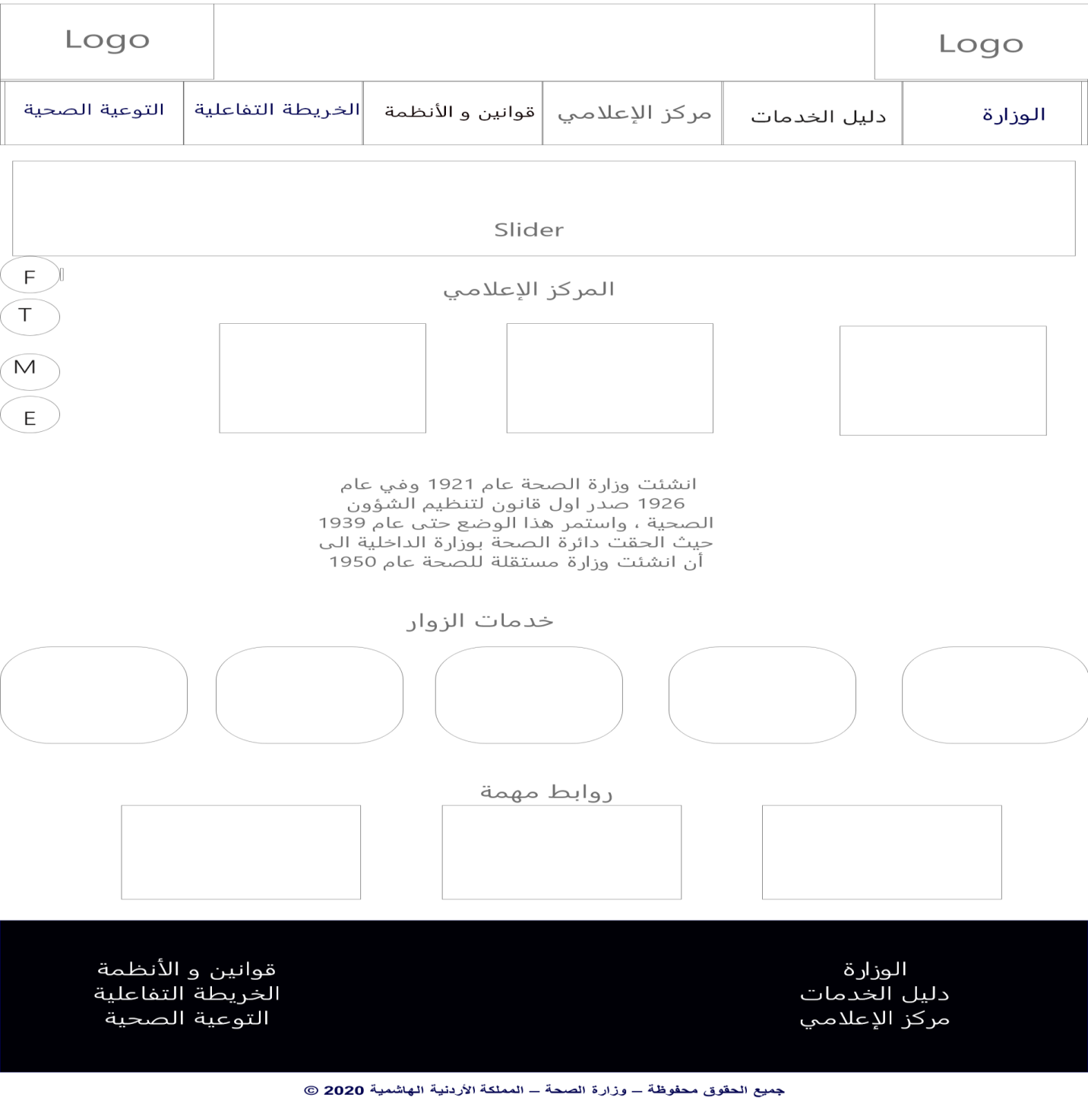

### Figure 3 Wireframe (Homepage).

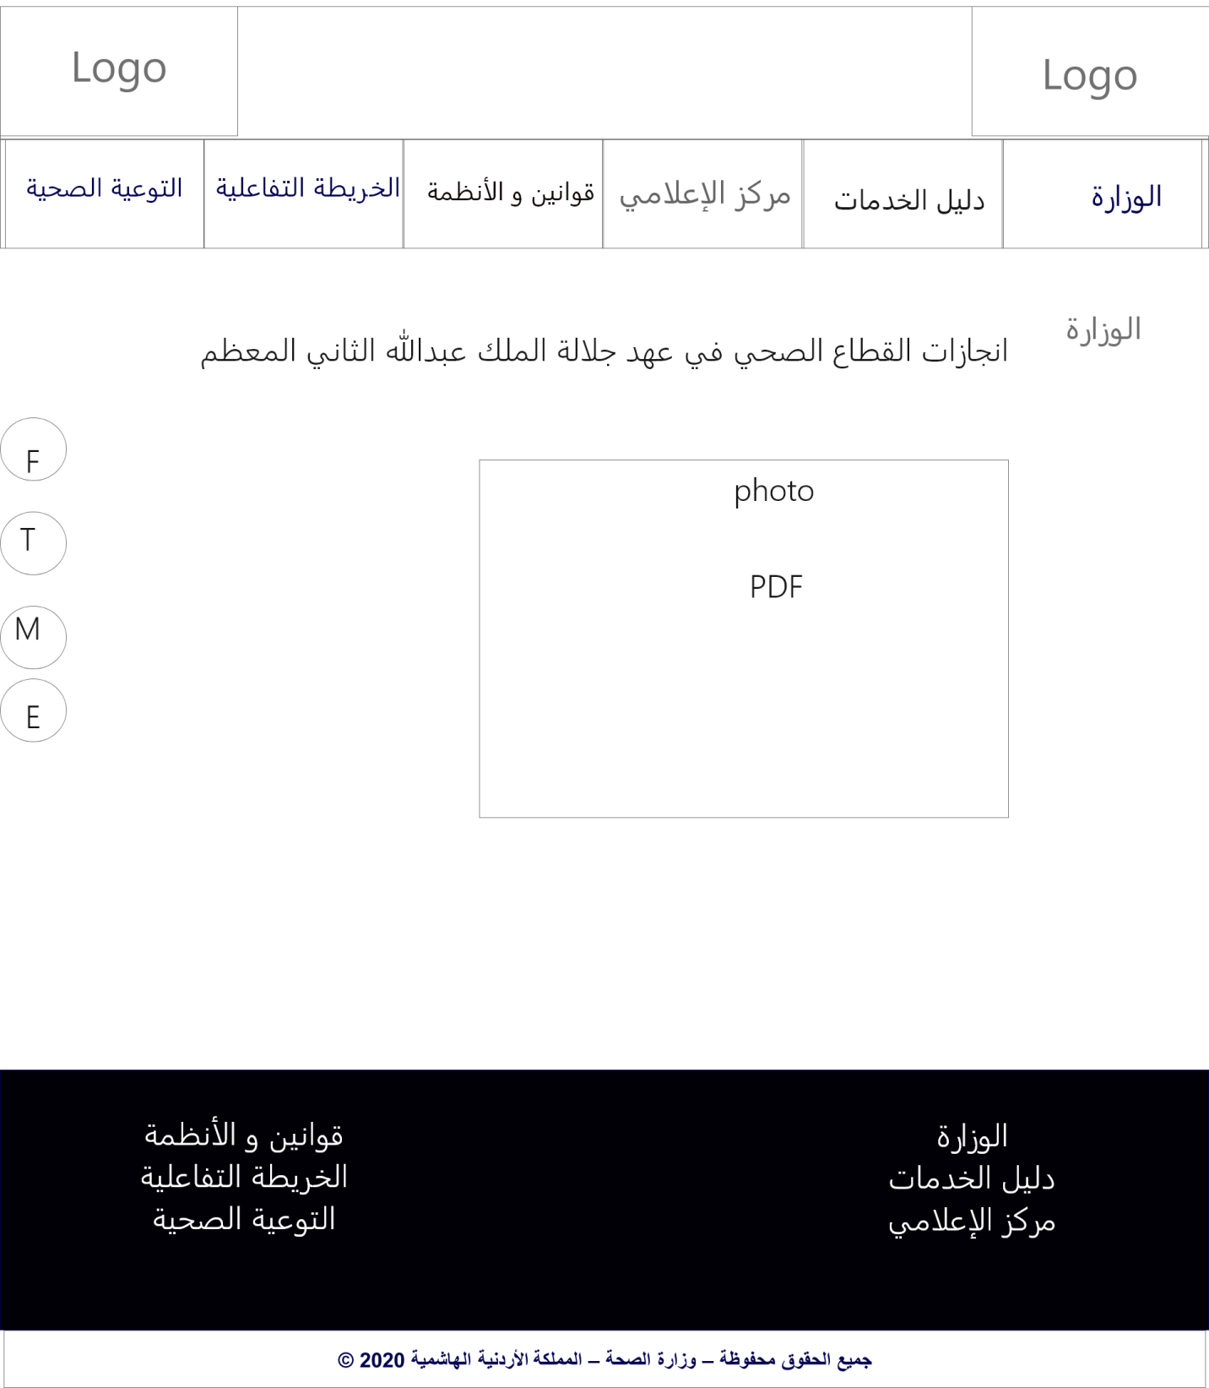

### Figure 4 Wireframe (Achievement).

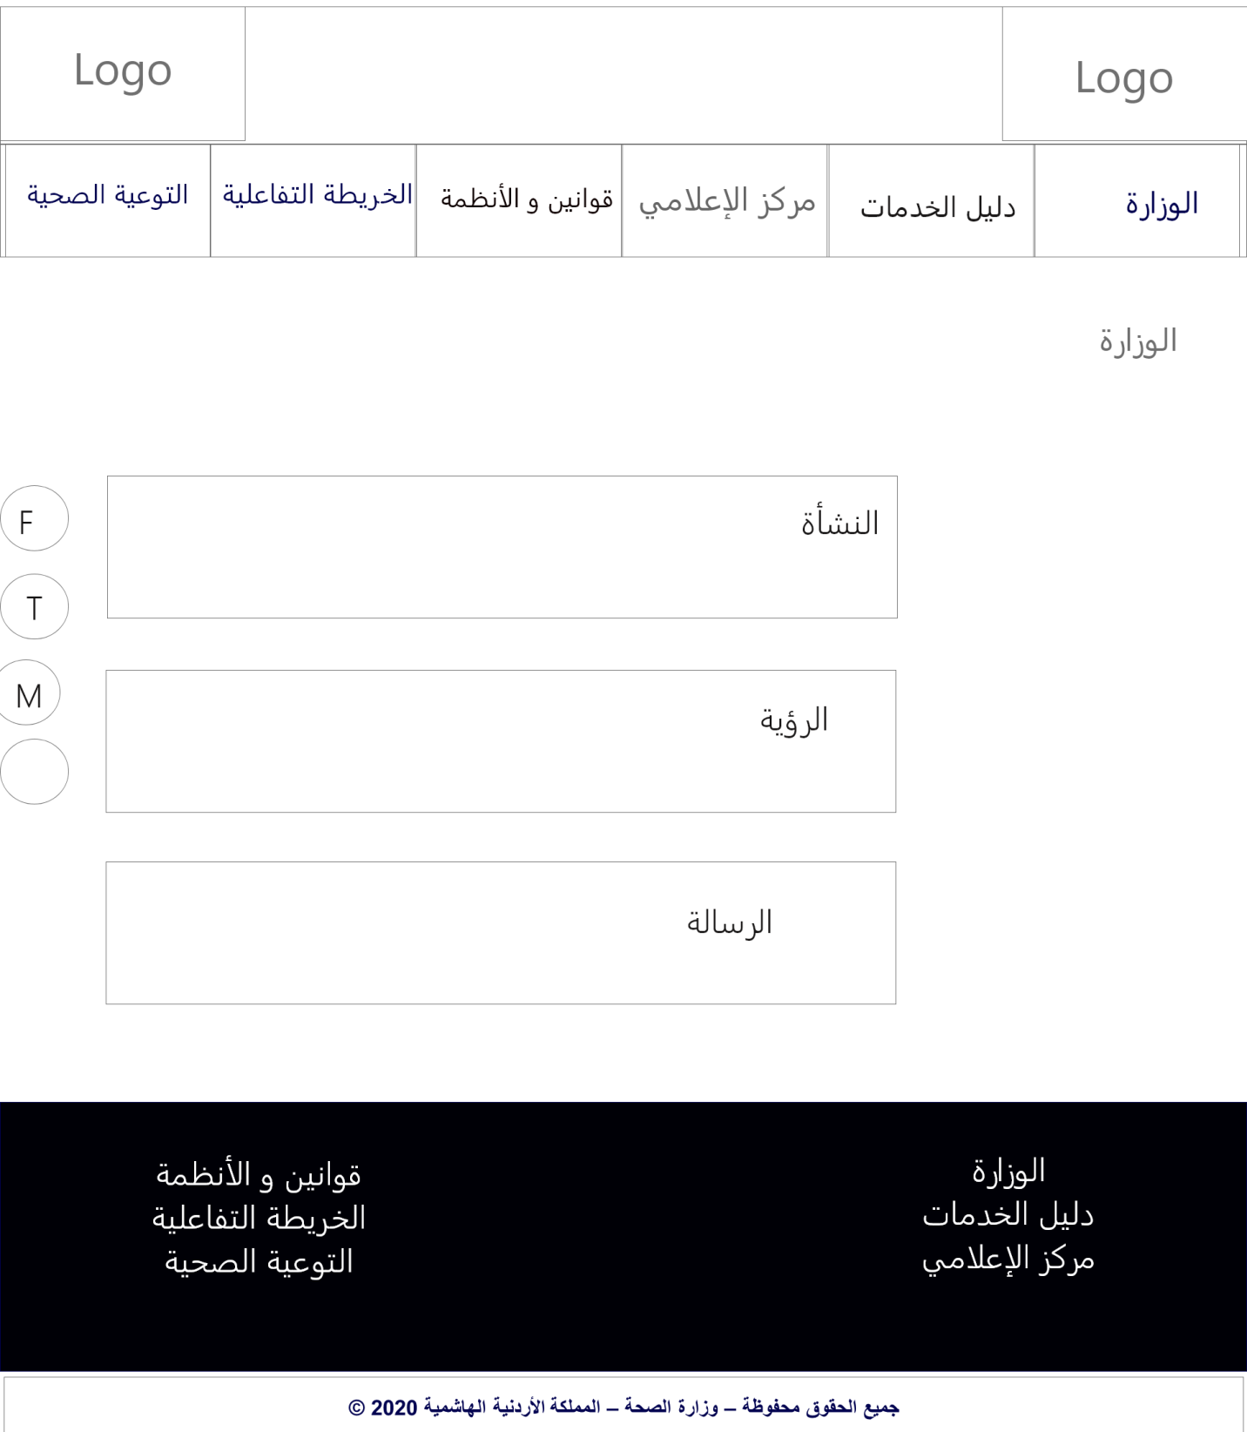

### Figure 5 Wireframe (Ministry).

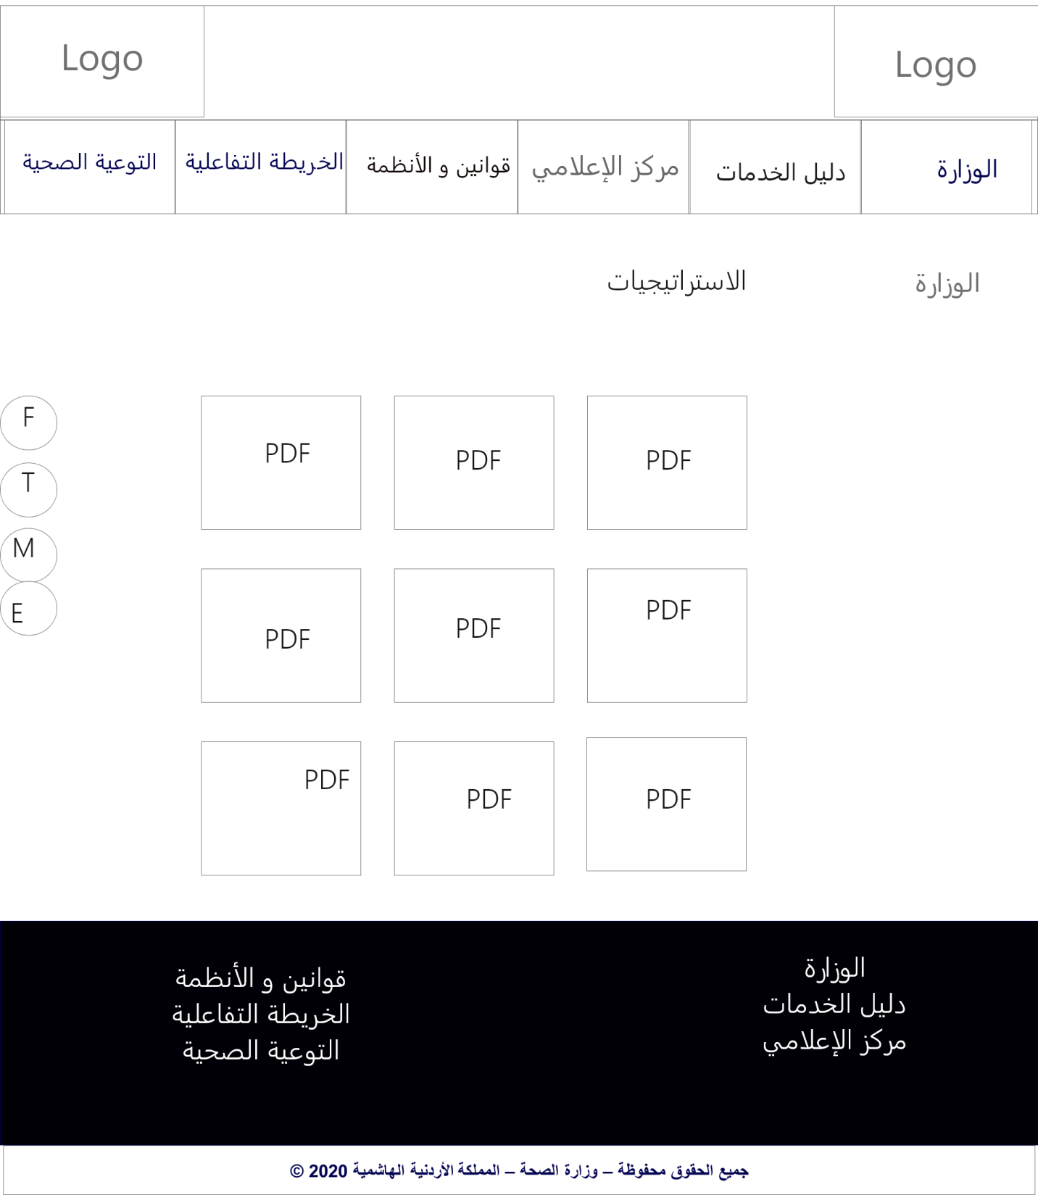

### Figure 6 Wireframe (Strategy).

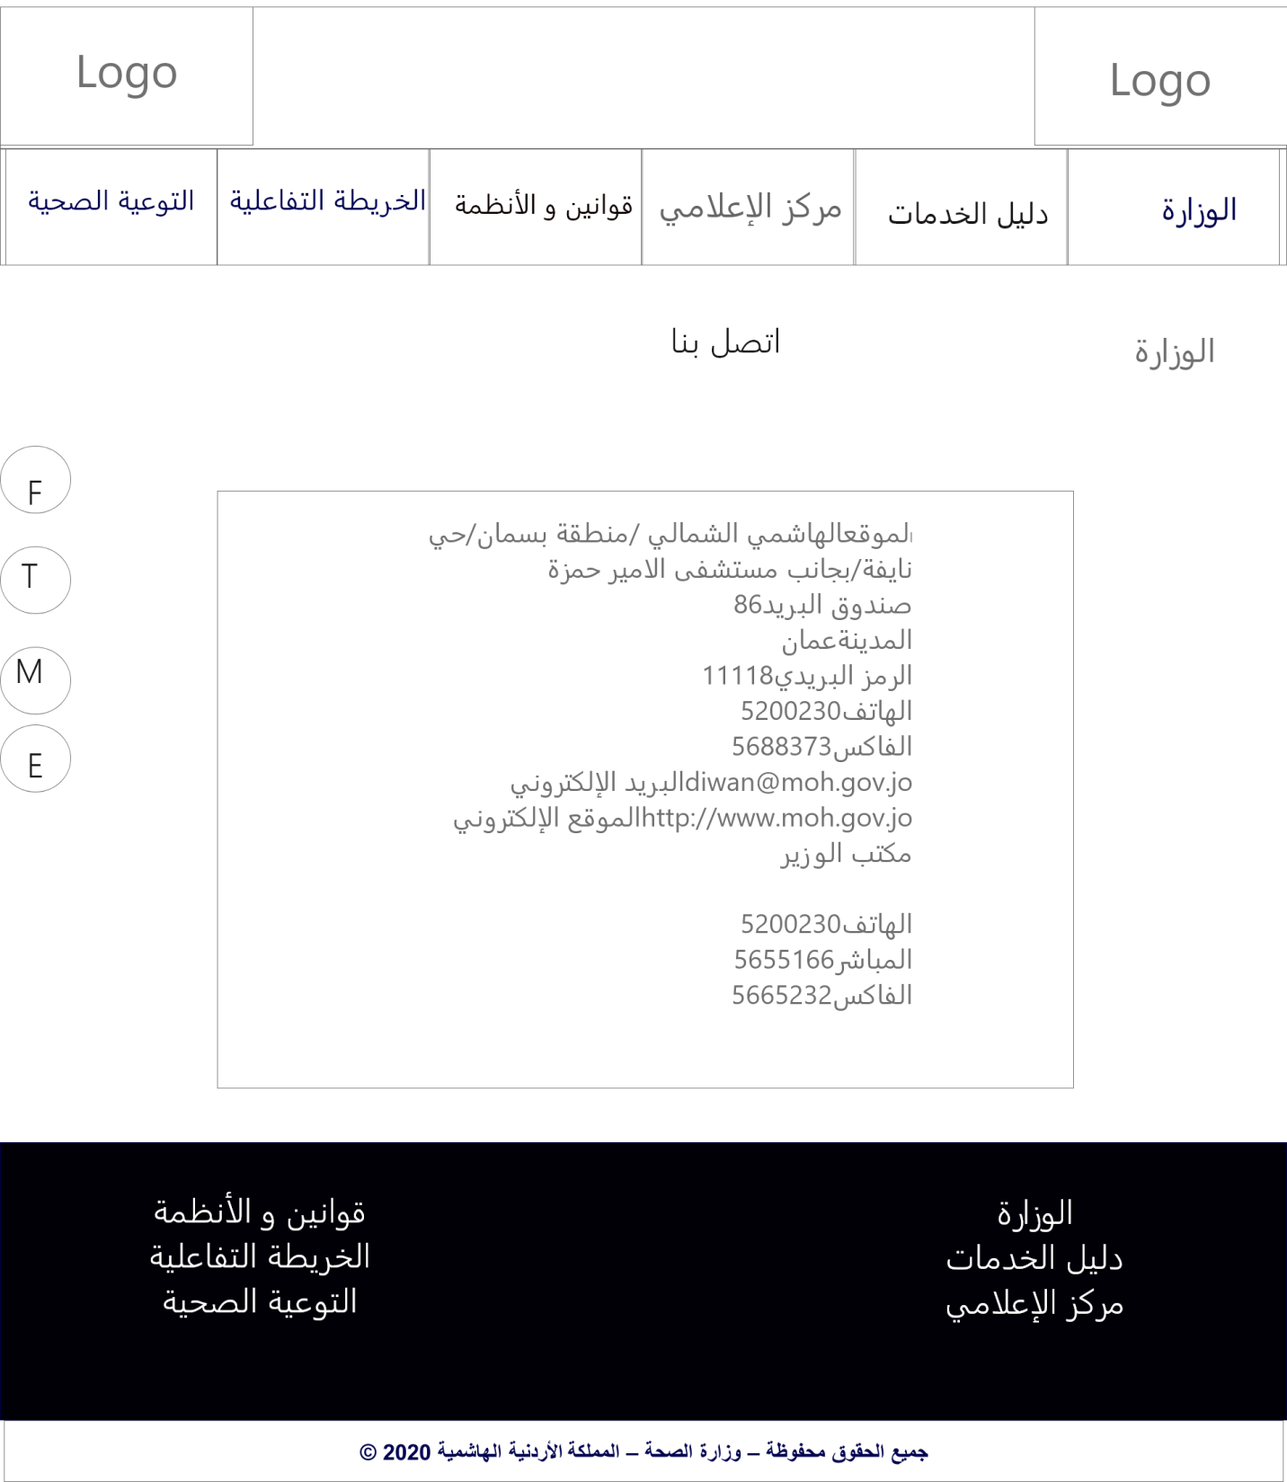

### Figure 7 Wireframe (Contact).

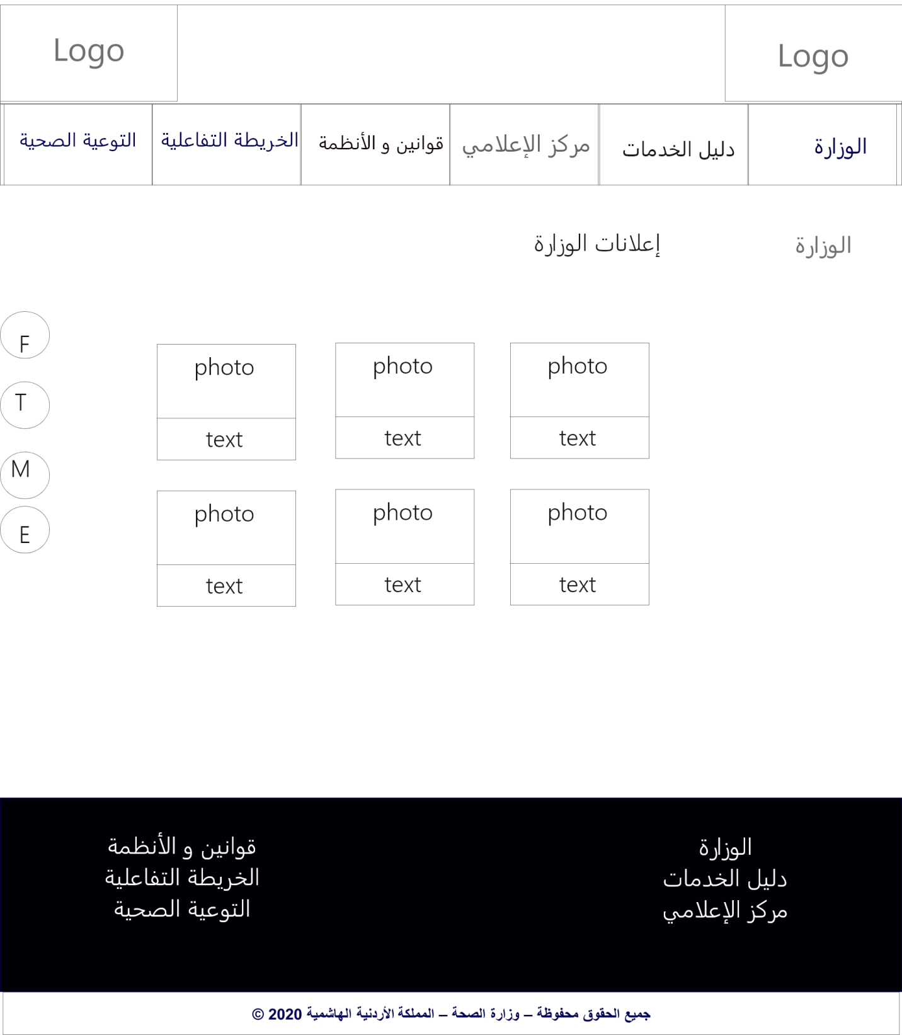

### Figure 8 Wireframe (Announcement).

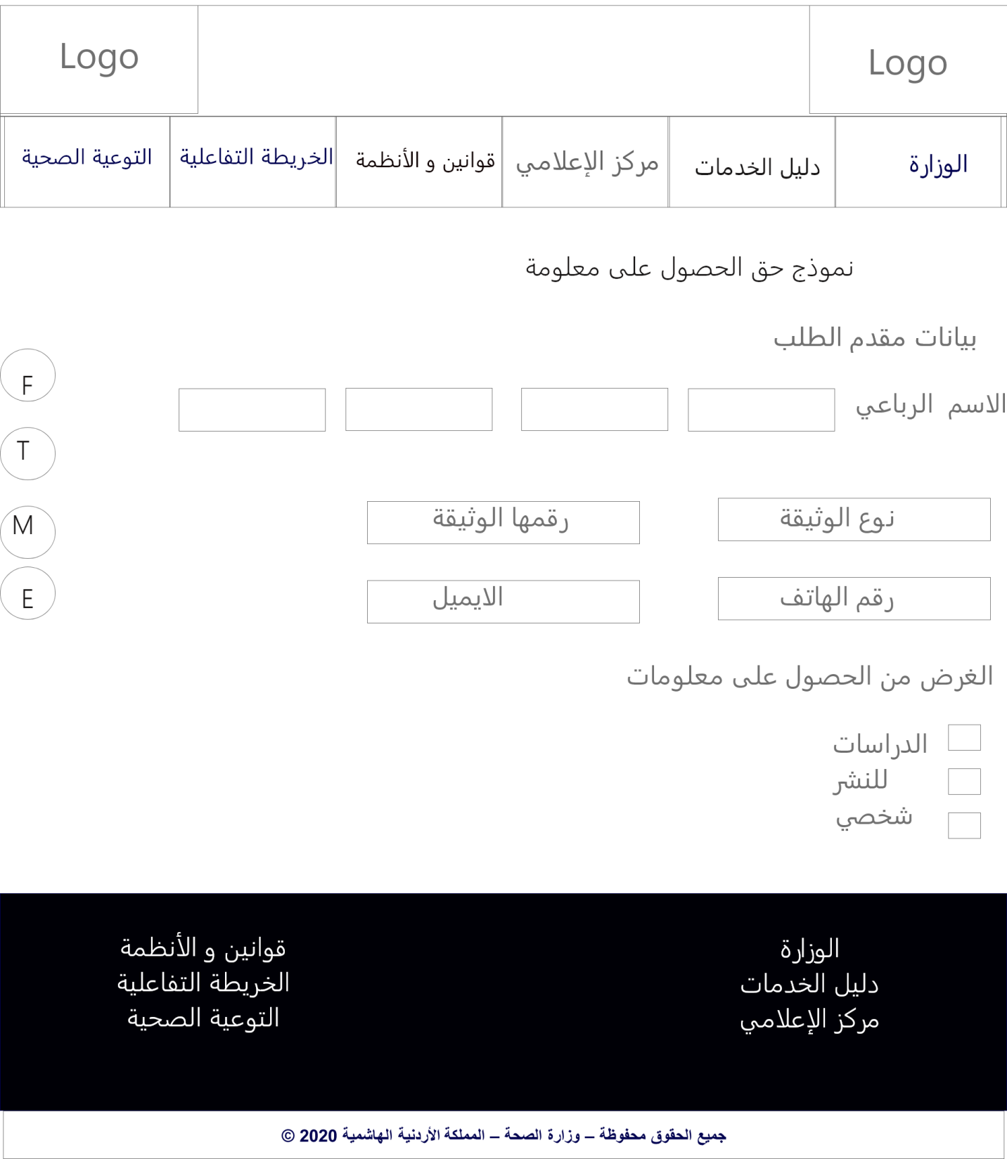

### Figure 9 Wireframe (Form).

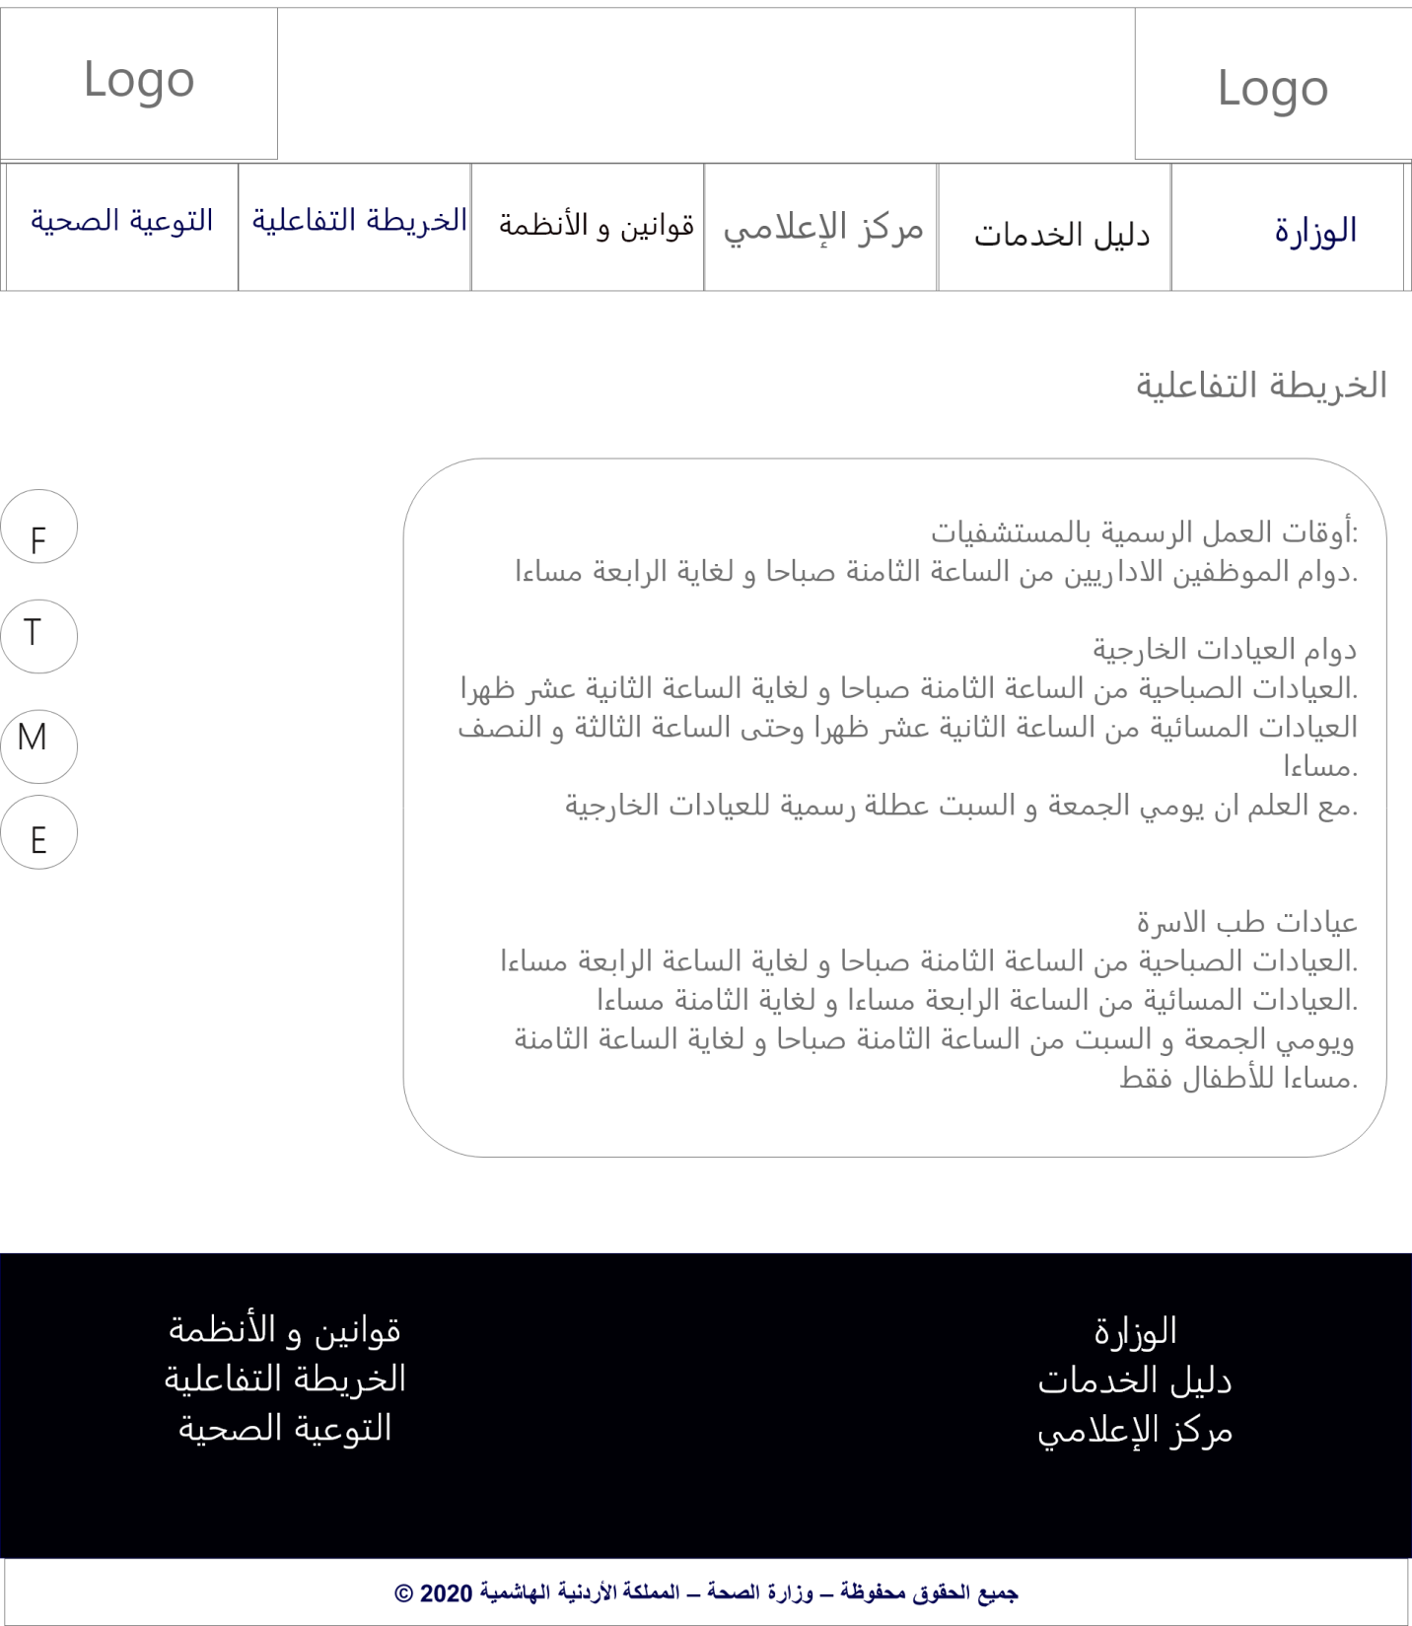

### Figure 10 Wireframe (Interactive Map).

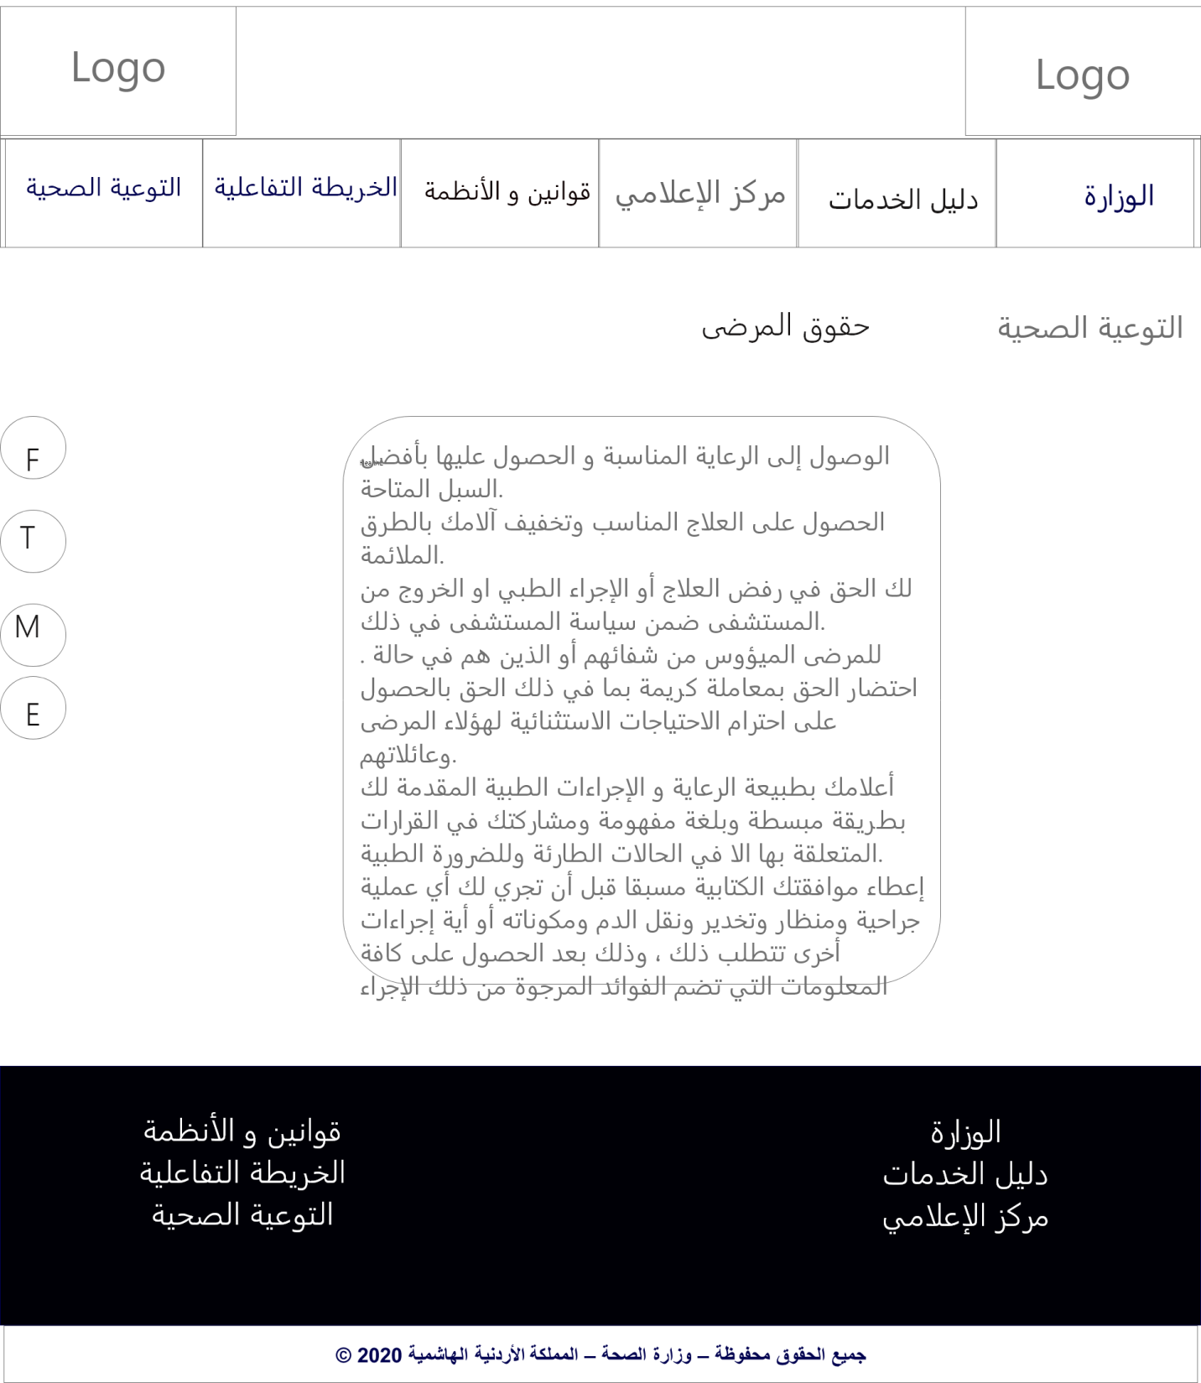

### Figure 11 Wireframe (Patient).

## Mockup

## Mockup will provide a medium-fidelity representation. Add colors, fonts, text (Lorem ipsum), images, logos and anything else that will shape your wireframe.

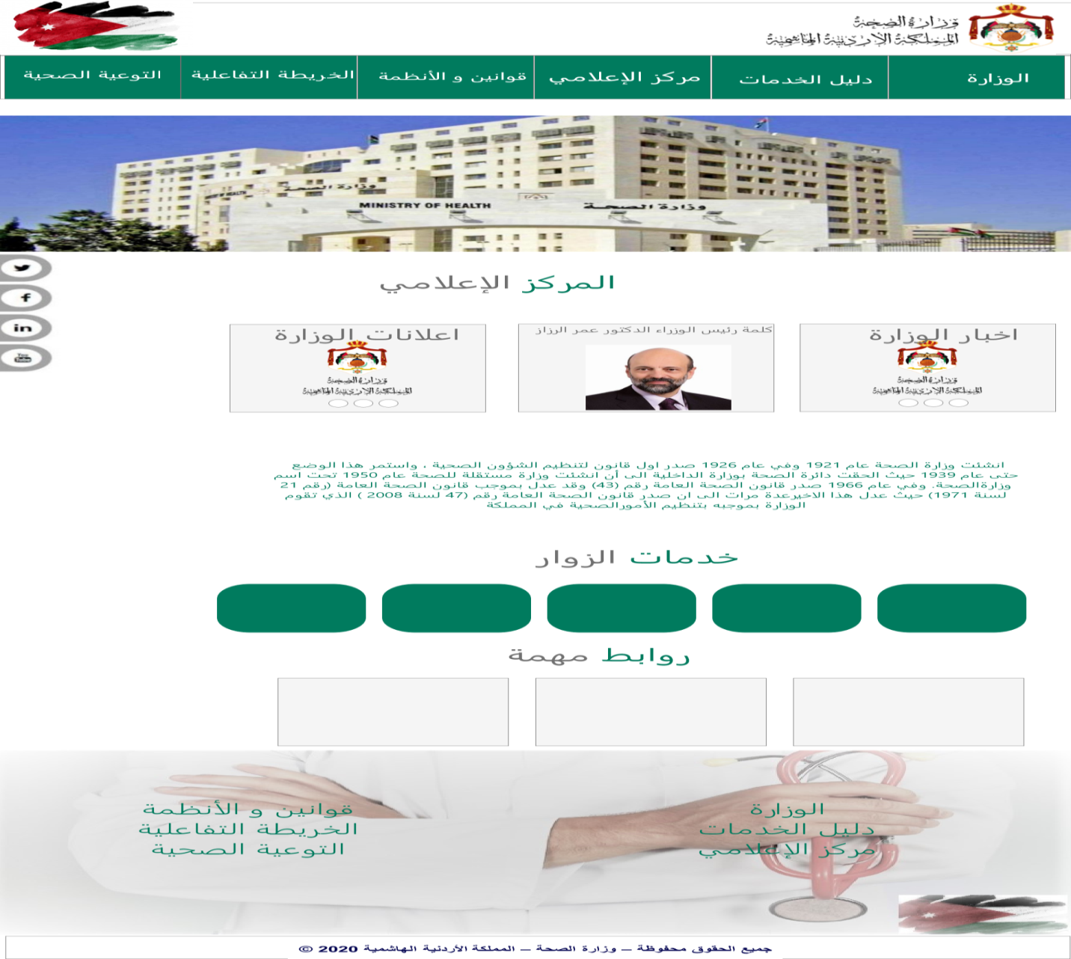

### Figure 12 Mockup (Homepage).

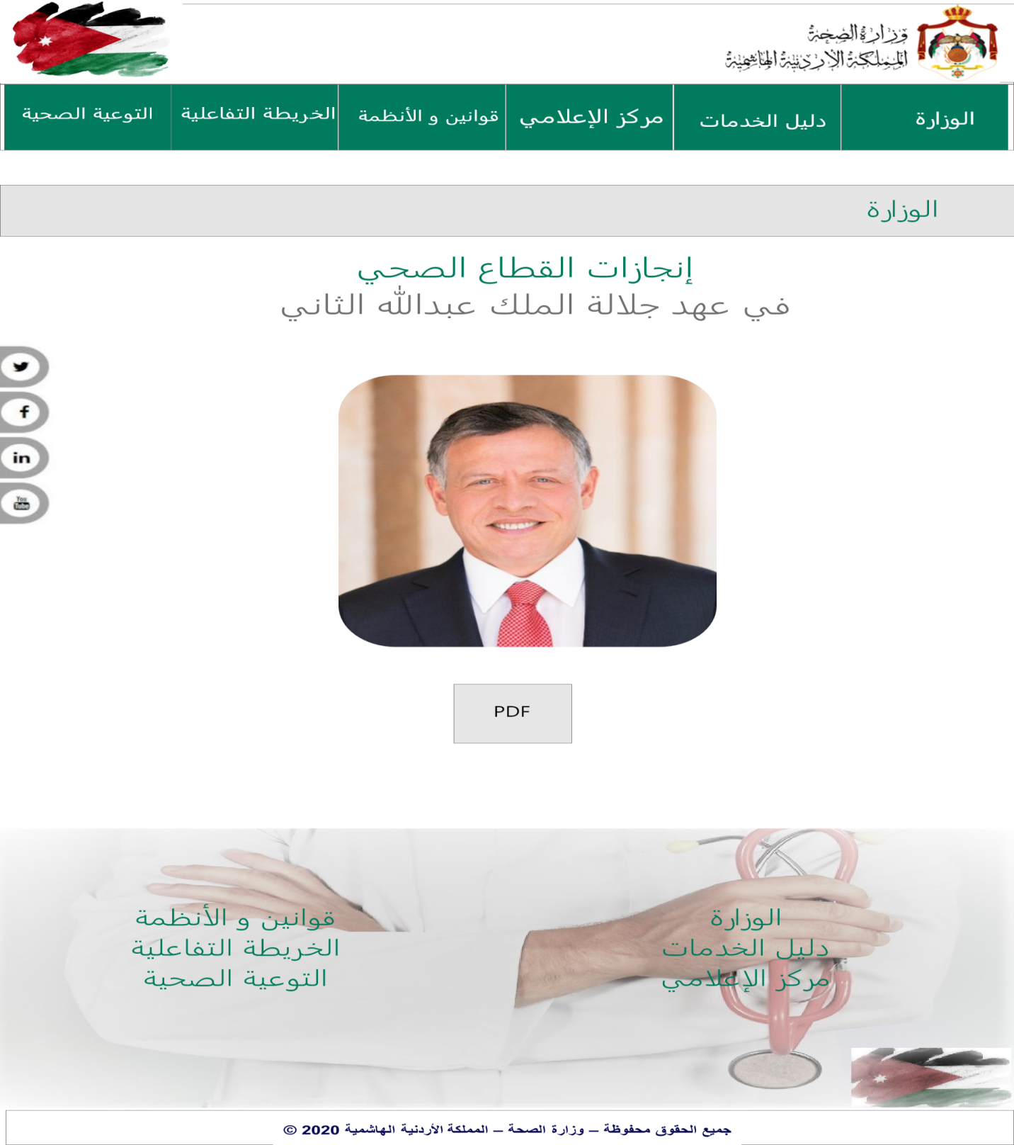

### Figure 13 Mockup (Achievement).

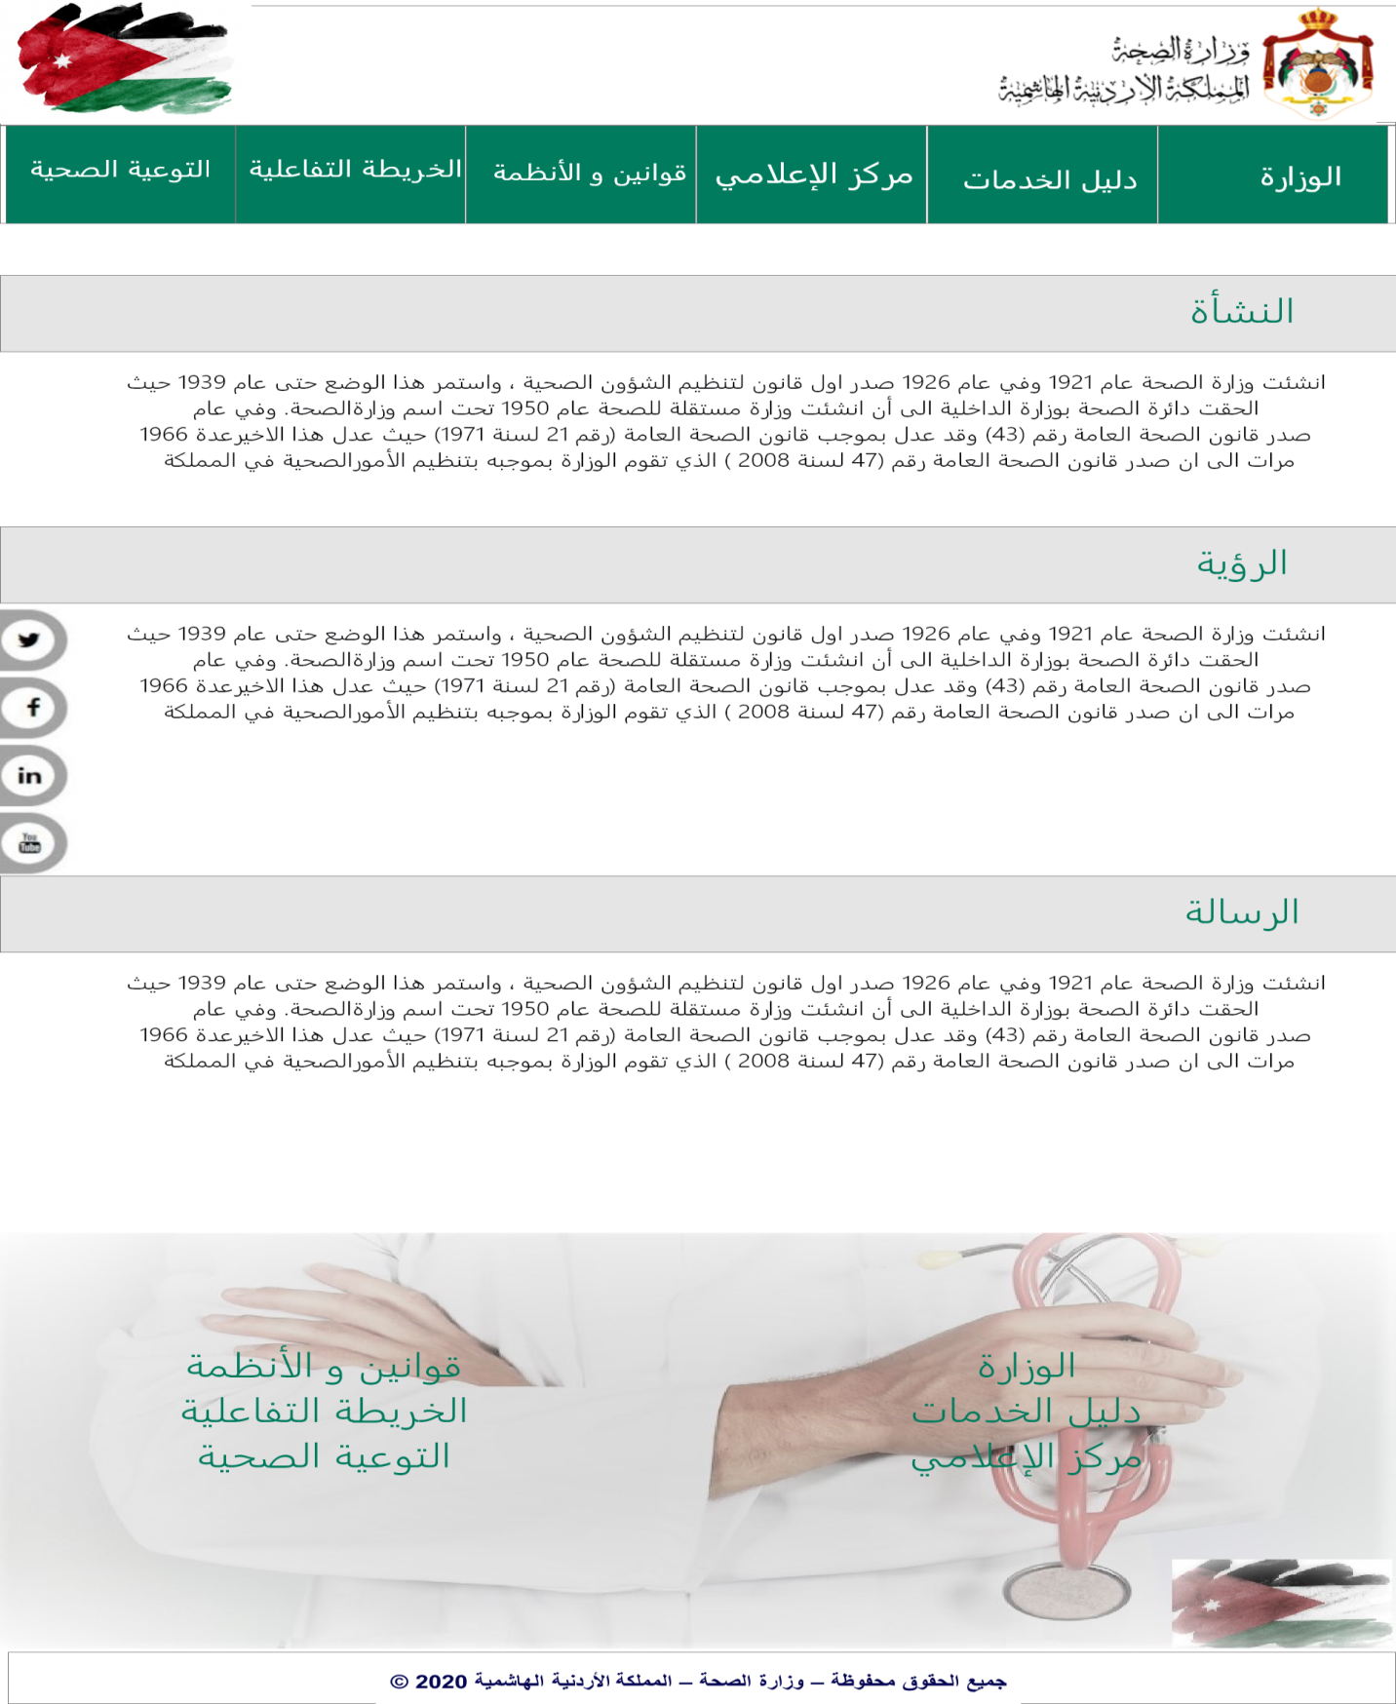

### Figure 14 Mockup (Ministry).

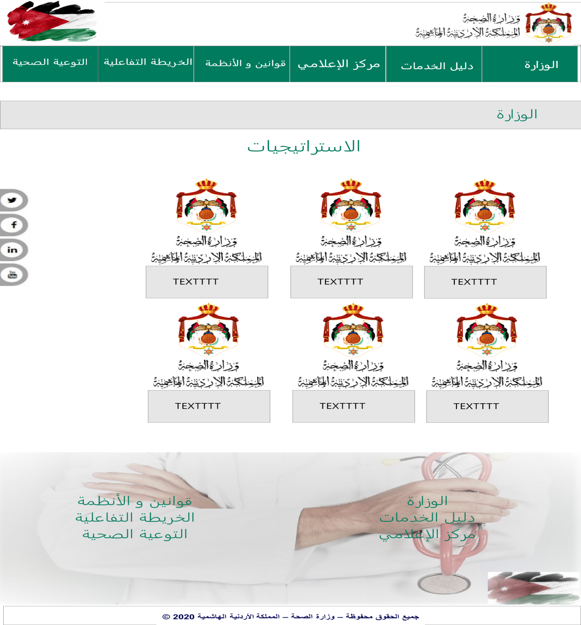

### Figure 15 Mockup (Strategy).

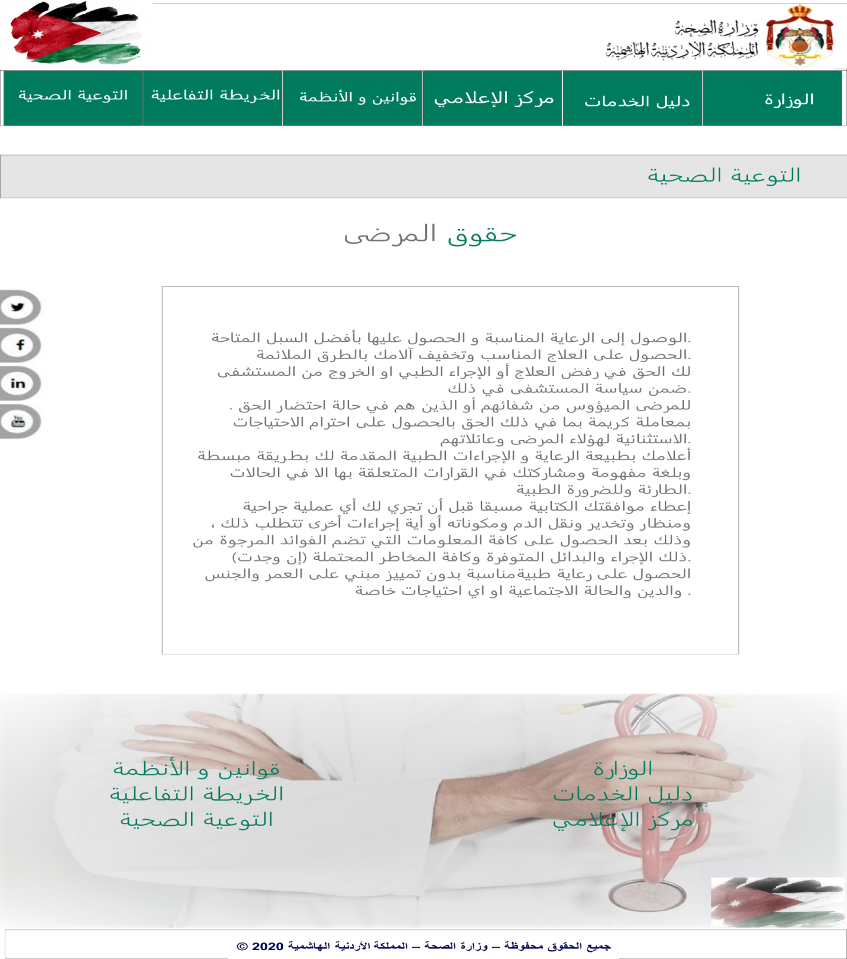

### Figure 16 Mockup (Patient).

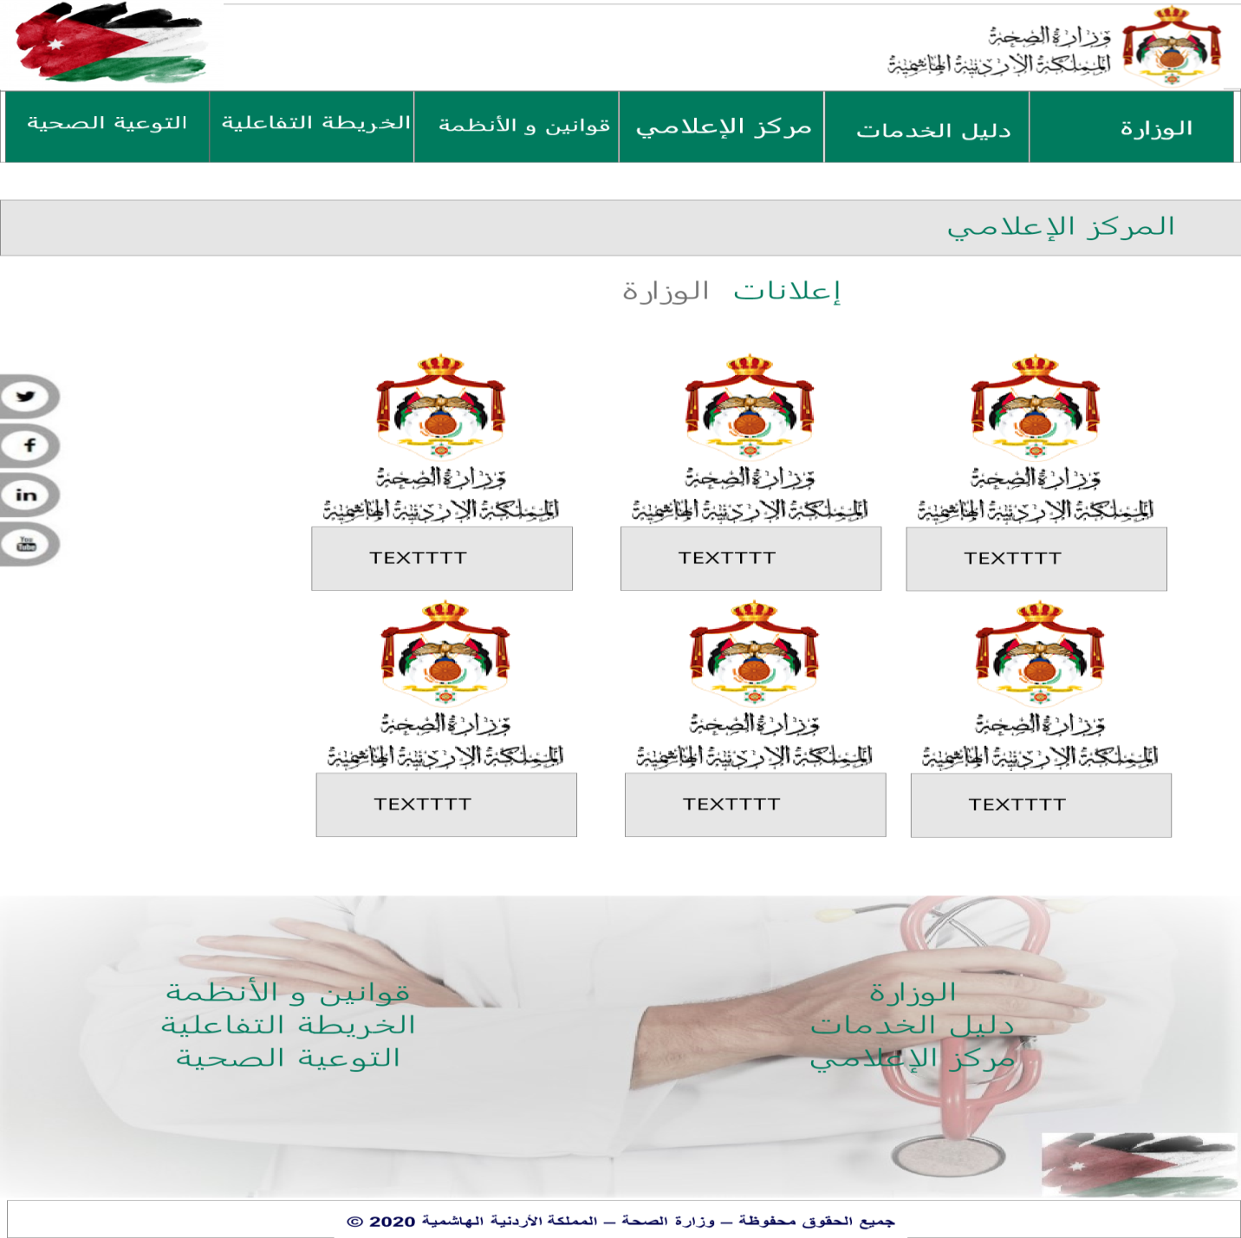

### Figure 17 Mockup (Announcement).

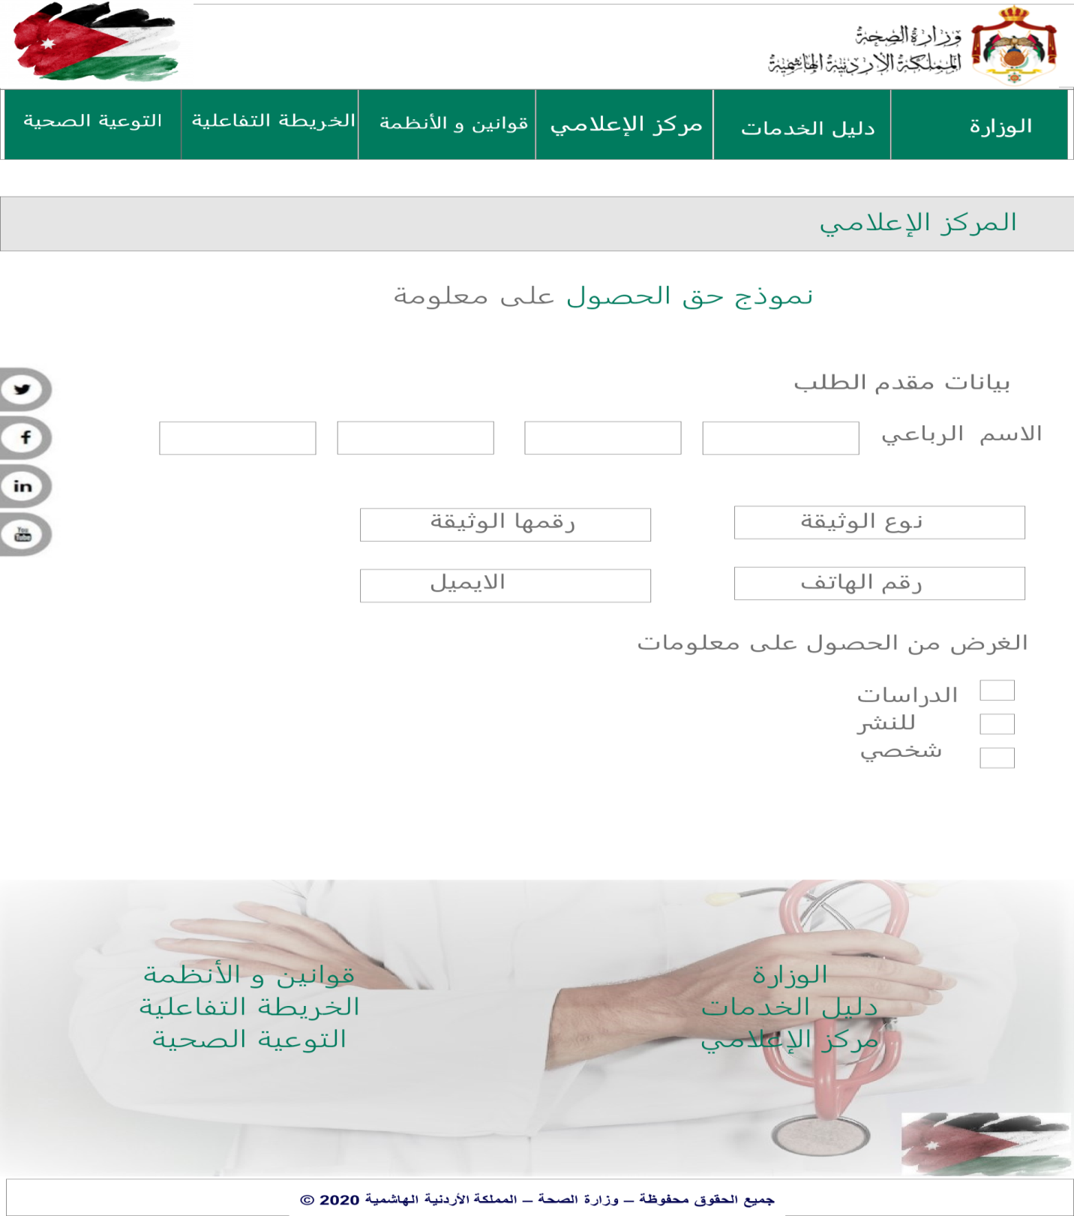

### Figure 18 Mockup (Form).

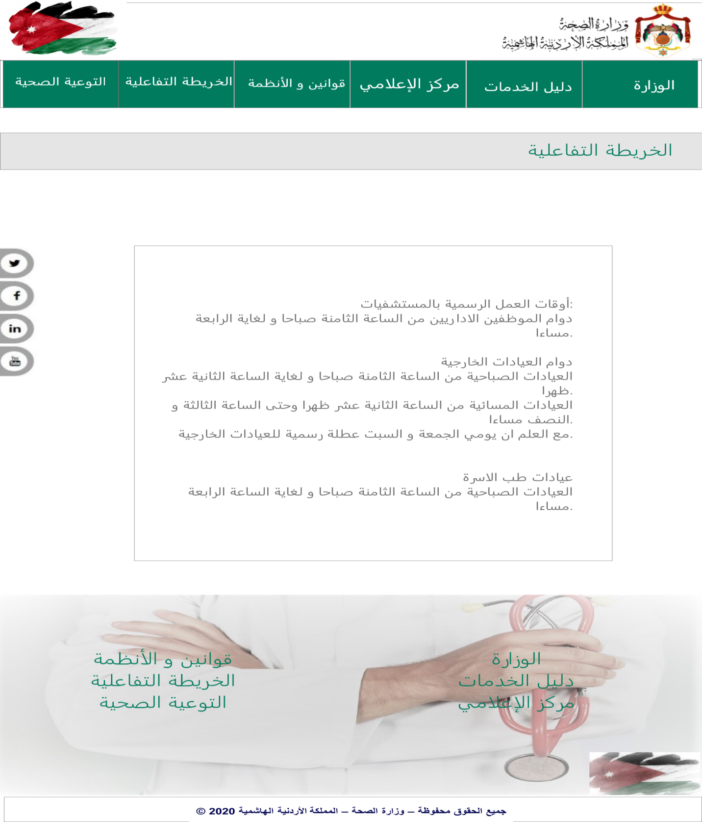

### Figure 19 Mockup (Interactive Map).

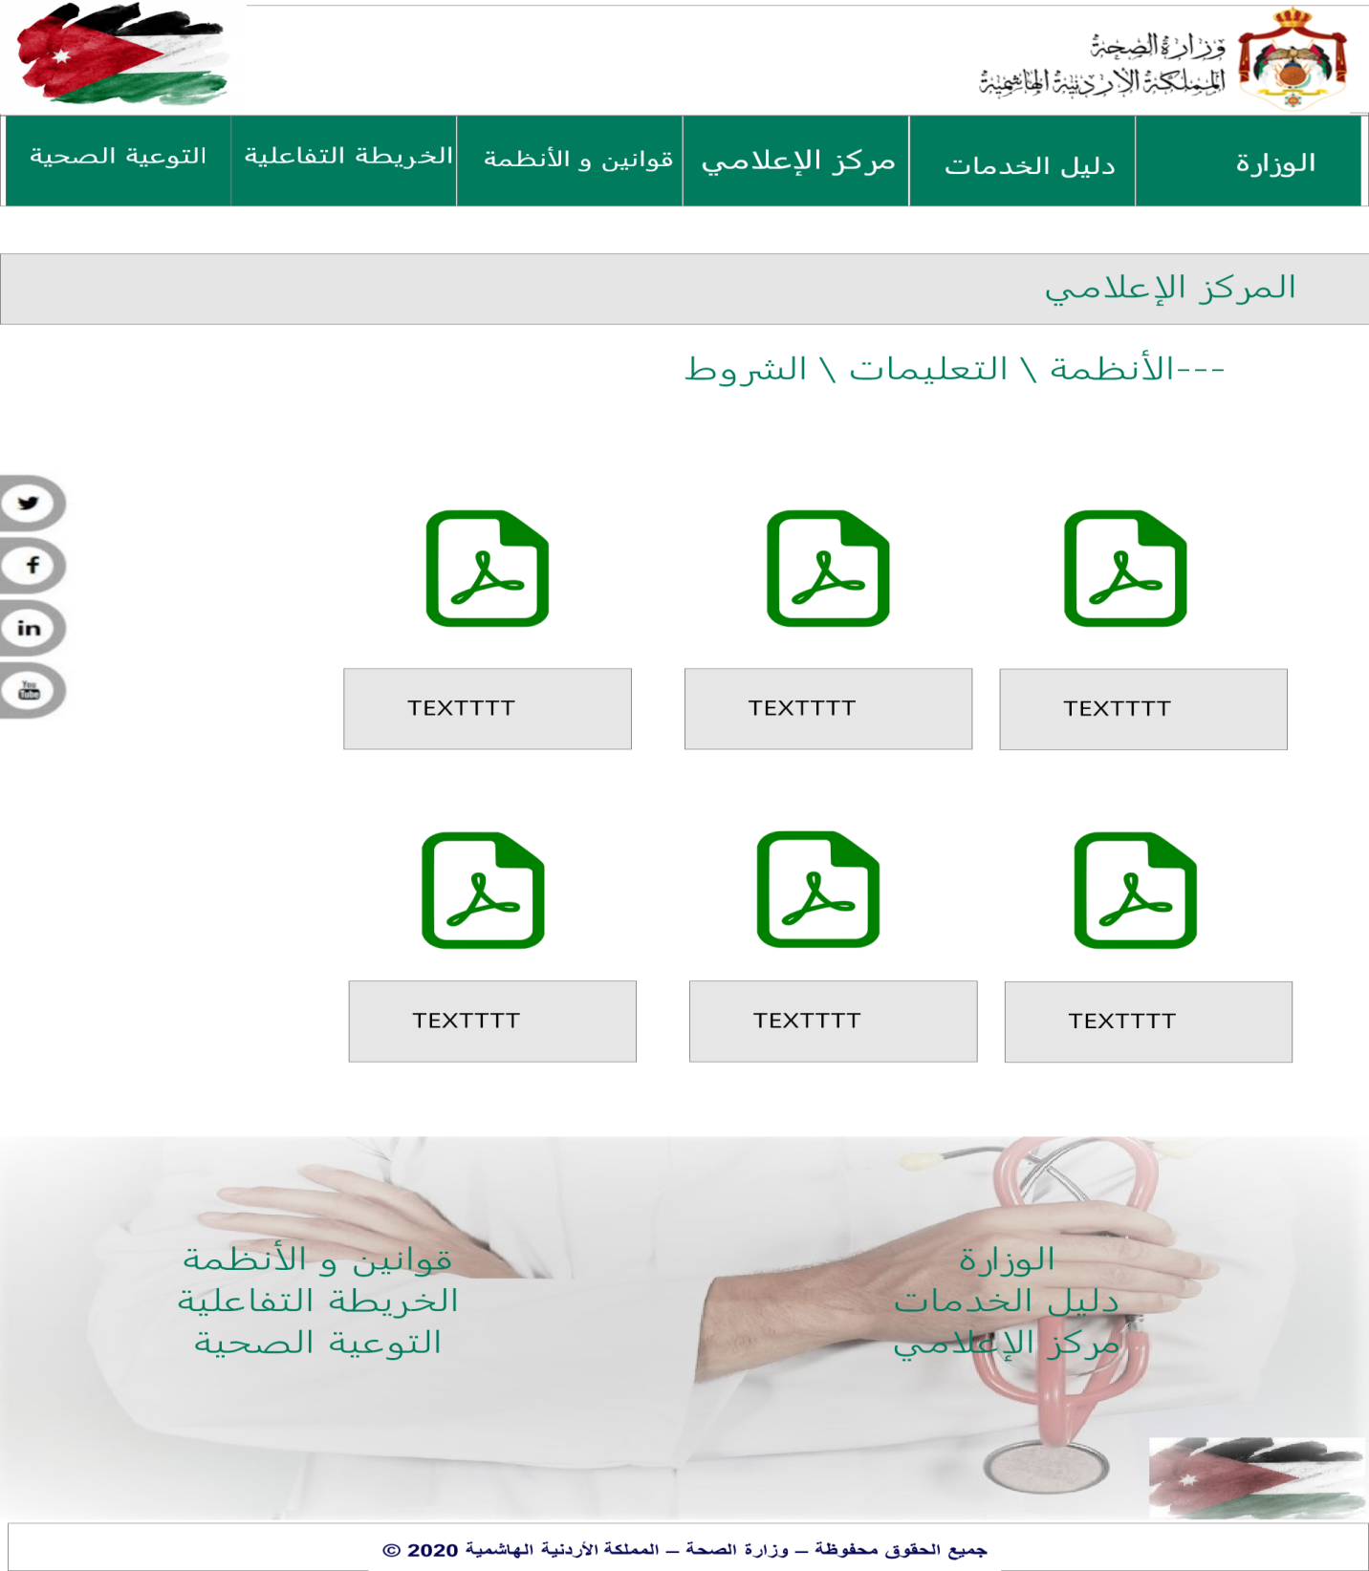

### Figure 20 Mockup (Rule).

# Prototype

Prototype represents the actual design.

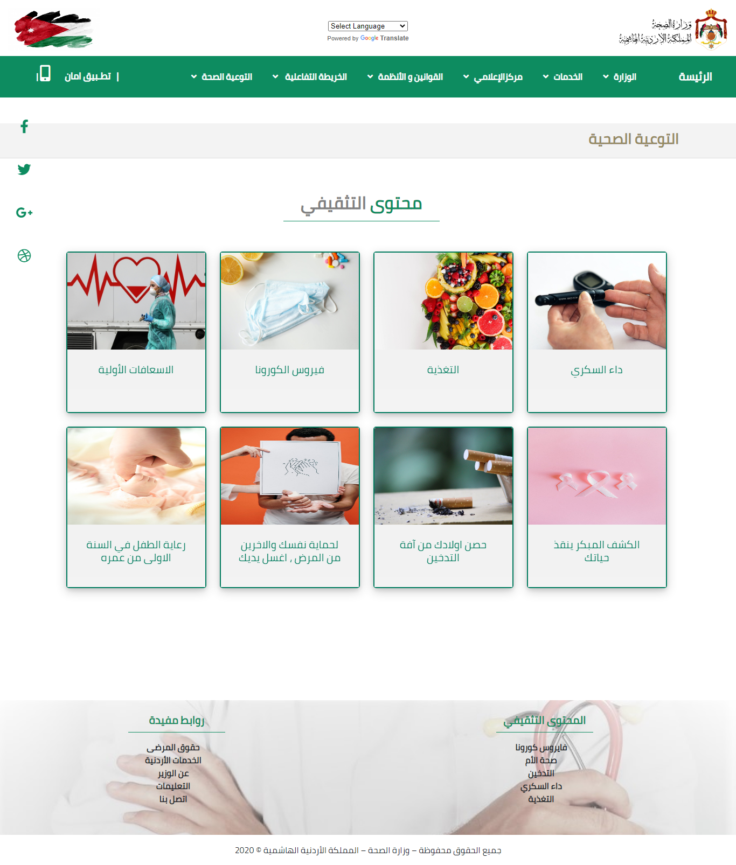

### Figure 21 Prototype (Health).

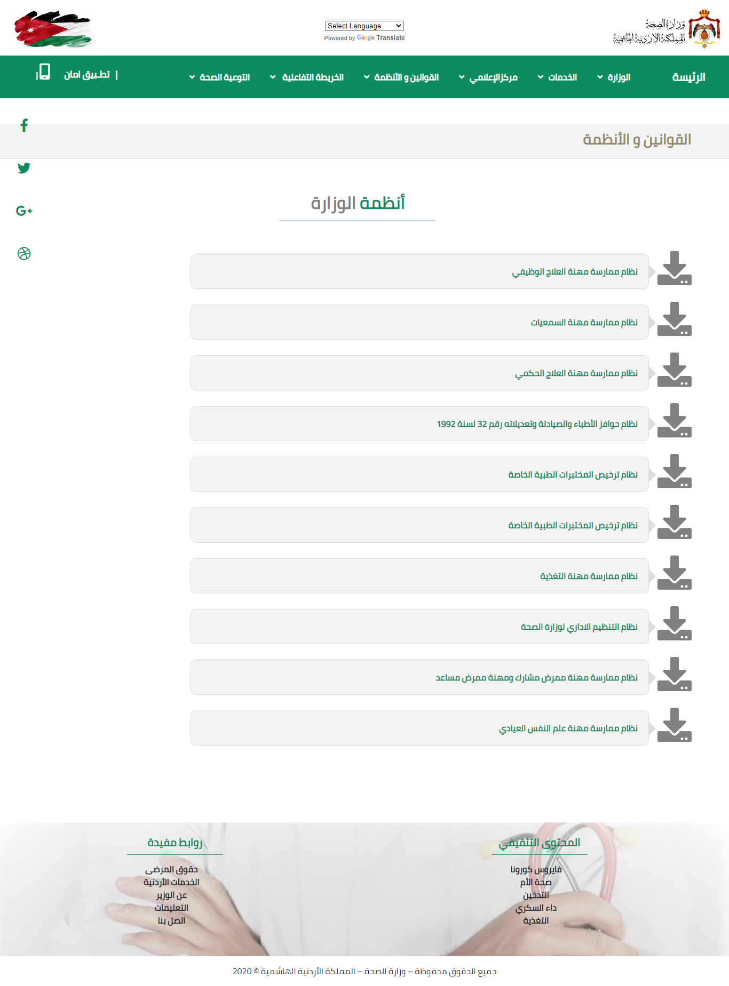

### Figure 22 Prototype (Rule).

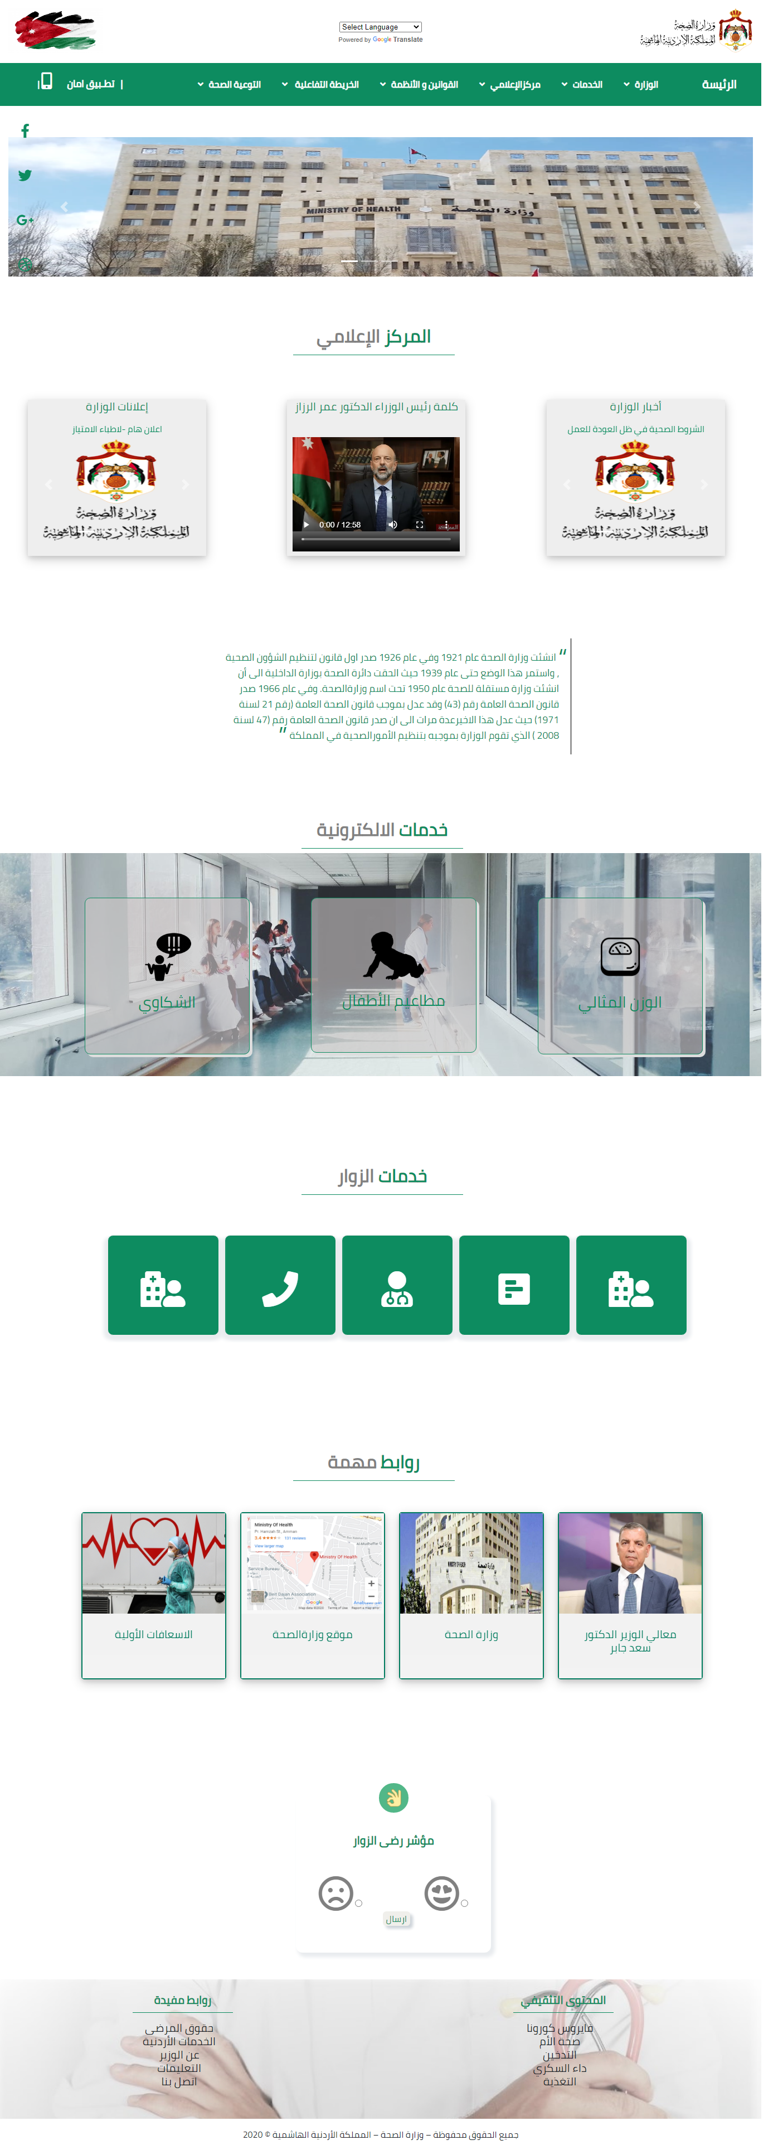

### Figure 23 Prototype (Homepage).

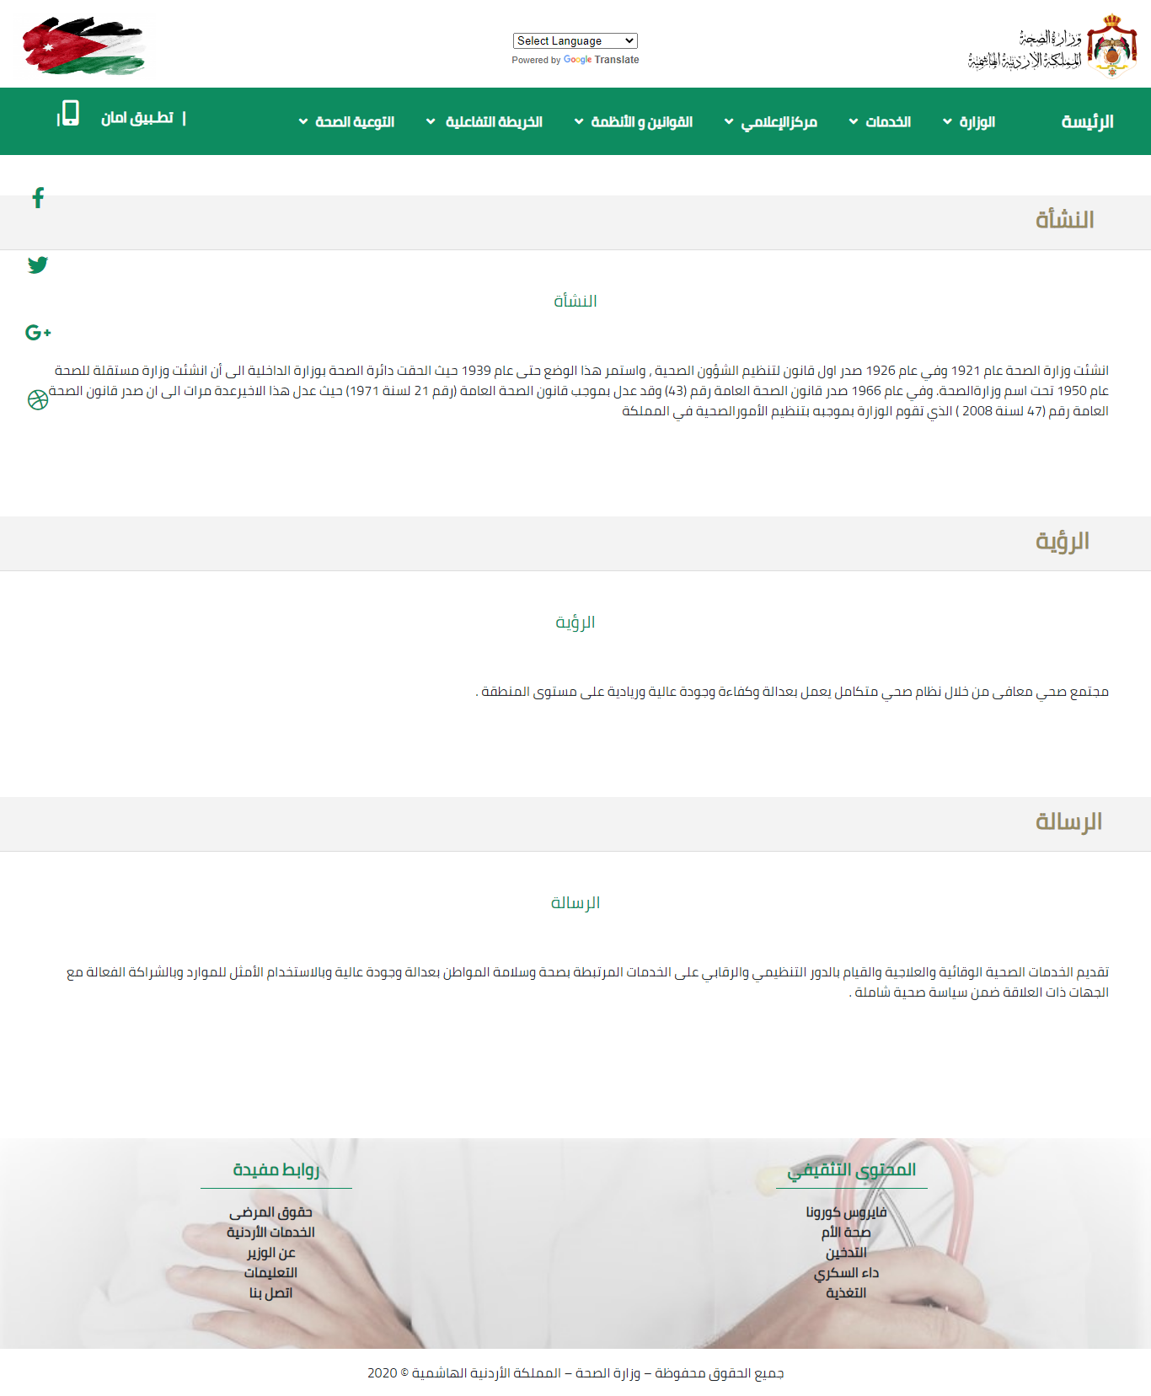

### Figure 24 Prototype (Minister).

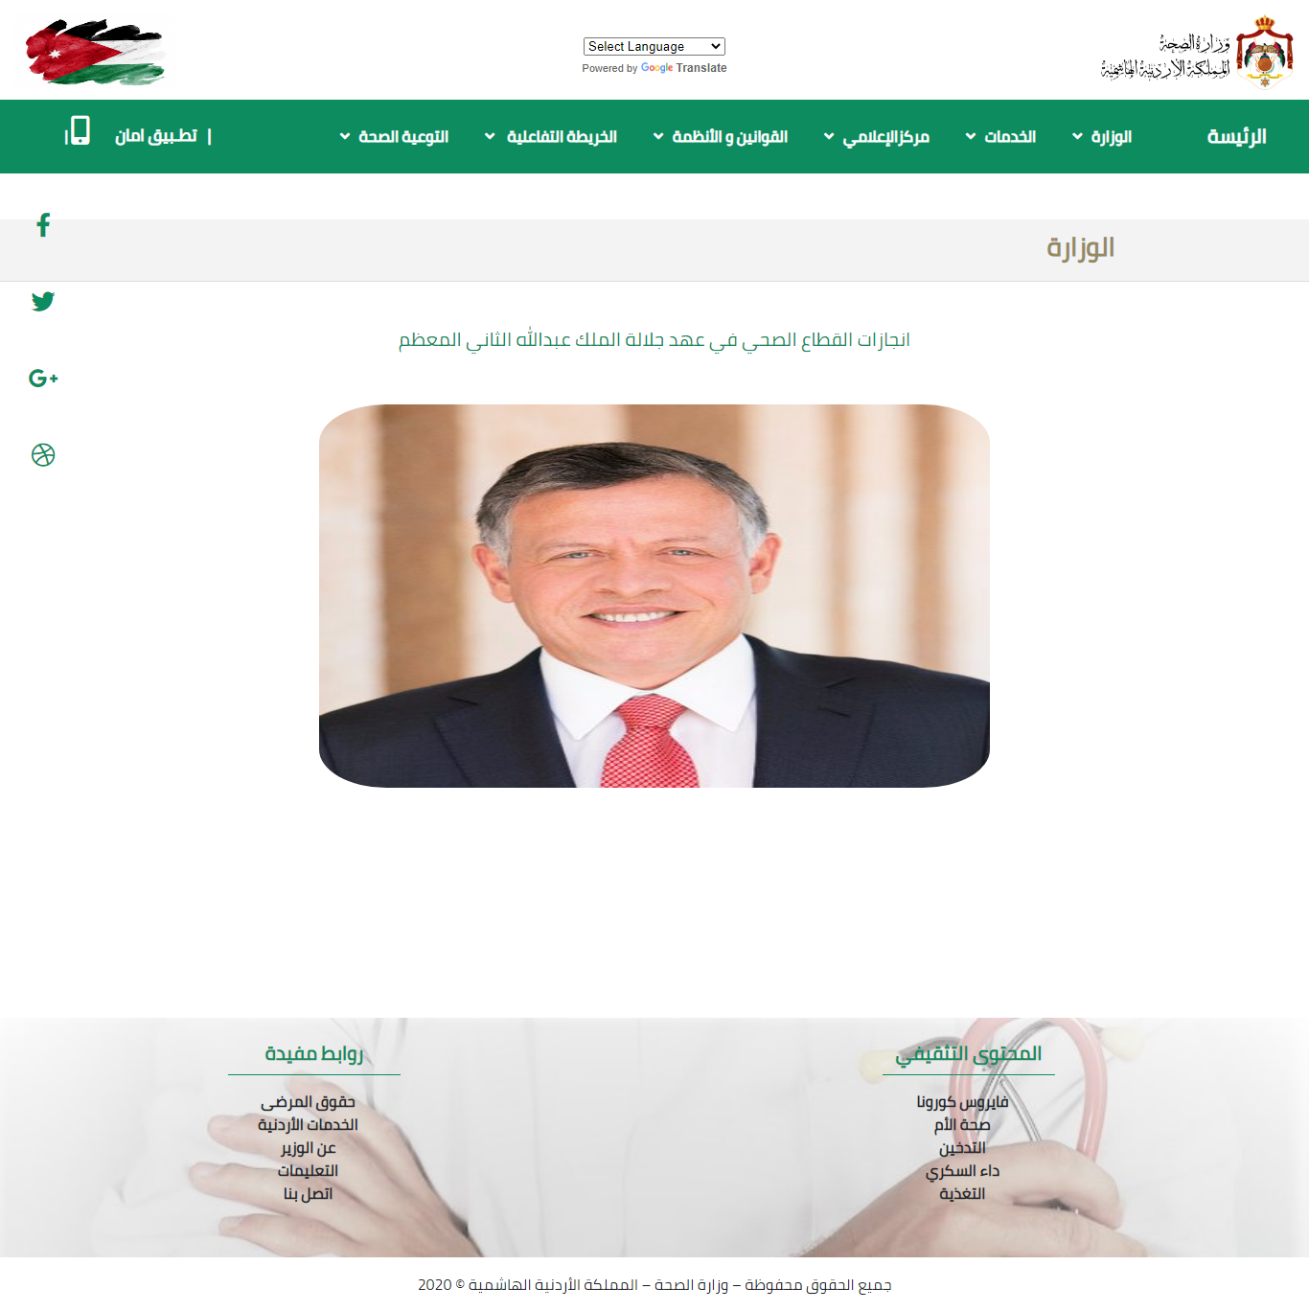

### Figure 25 Prototype (Achievement).

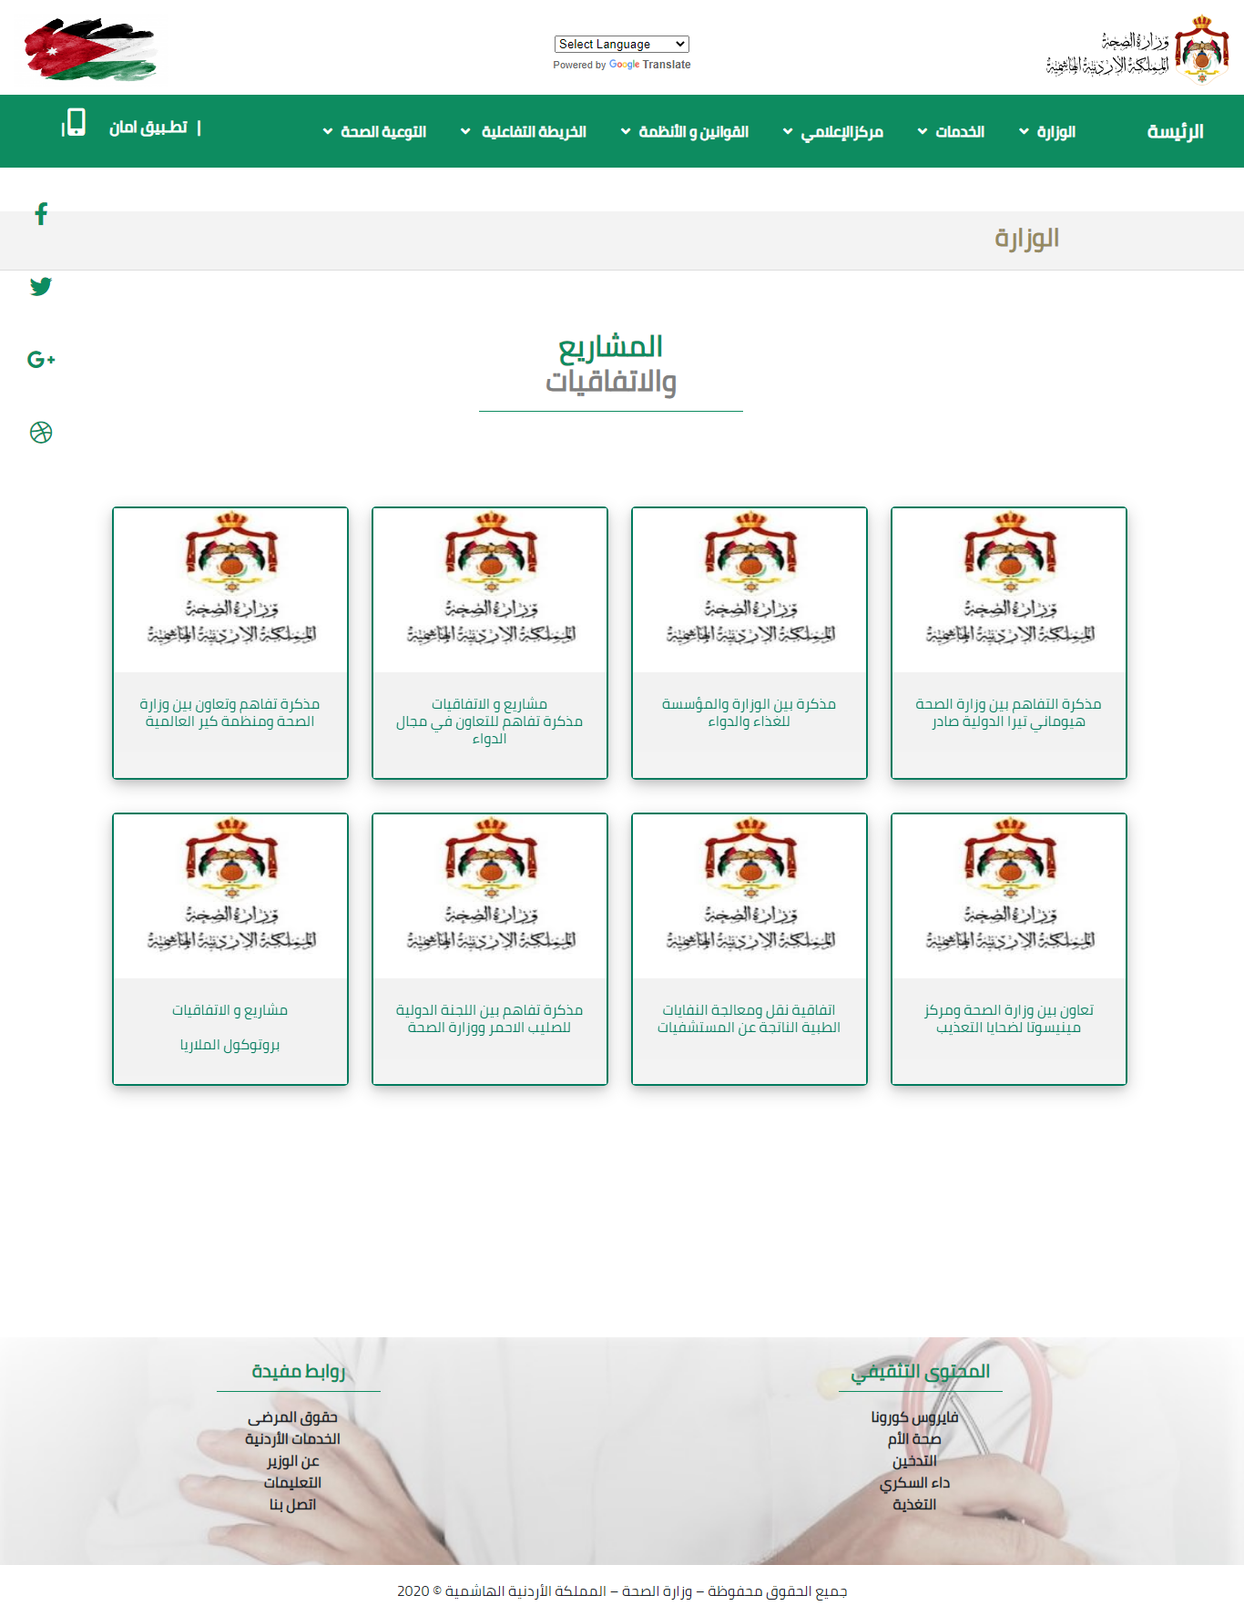

### Figure 26 Prototype (Project).

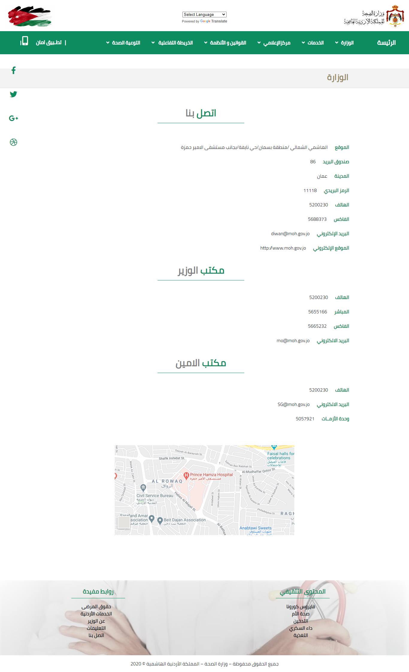

### Figure 27 Prototype (Contact).

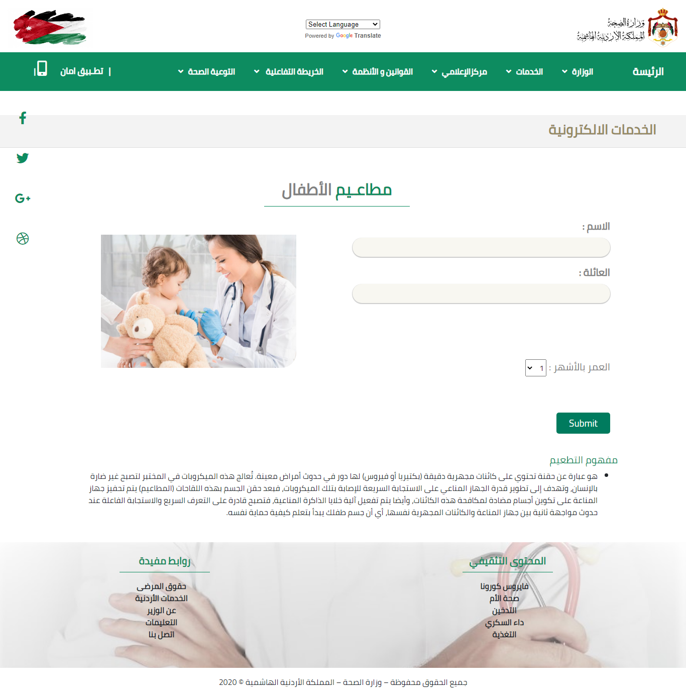

### Figure 28 Prototype (Vaccines).

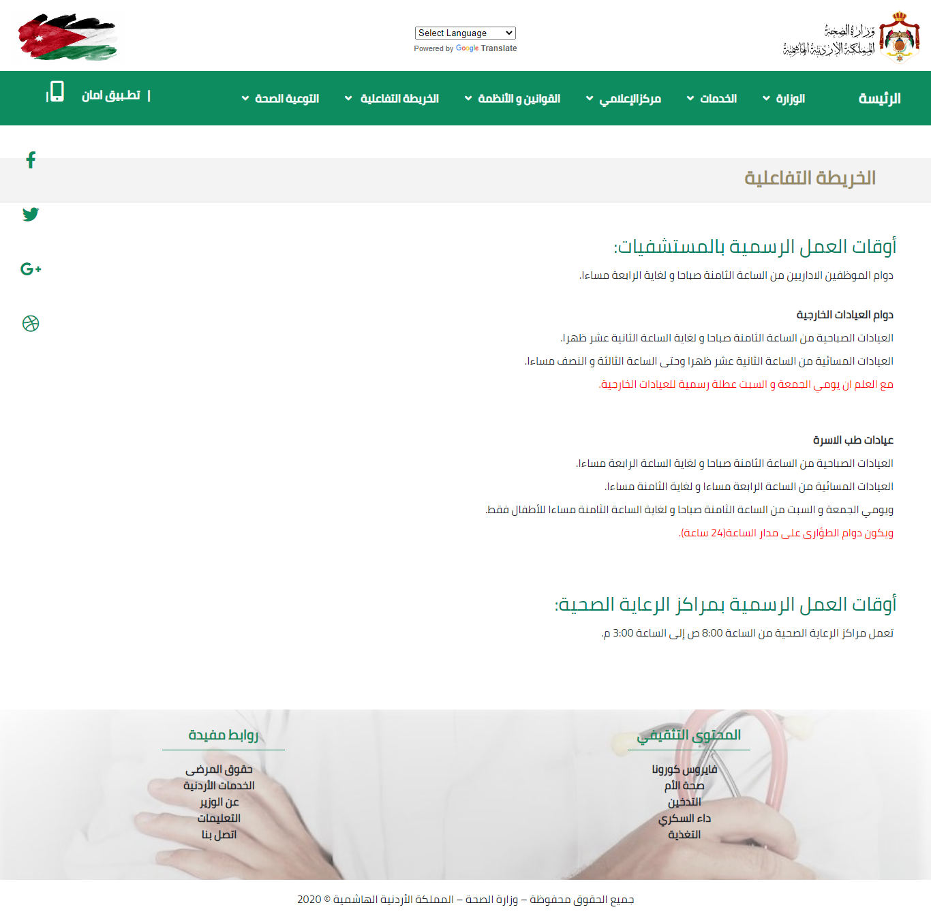

### Figure 29 Prototype (Interactive Map).

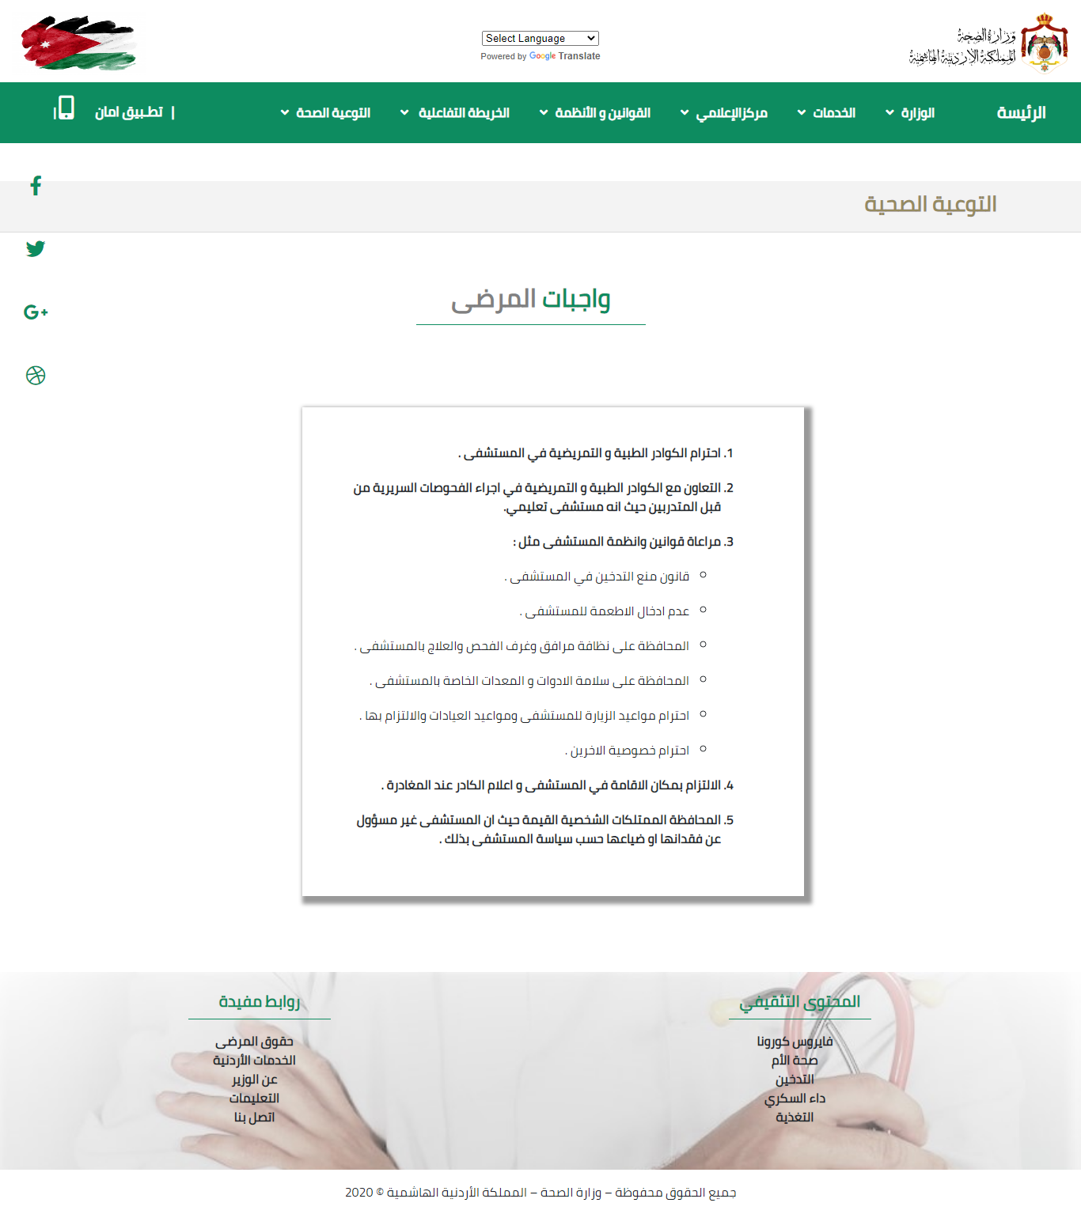

### Figure 30 Prototype (Patient).

# ERD

The ERD represents the entity relationship diagram, is a type of structural diagram for use in database design. 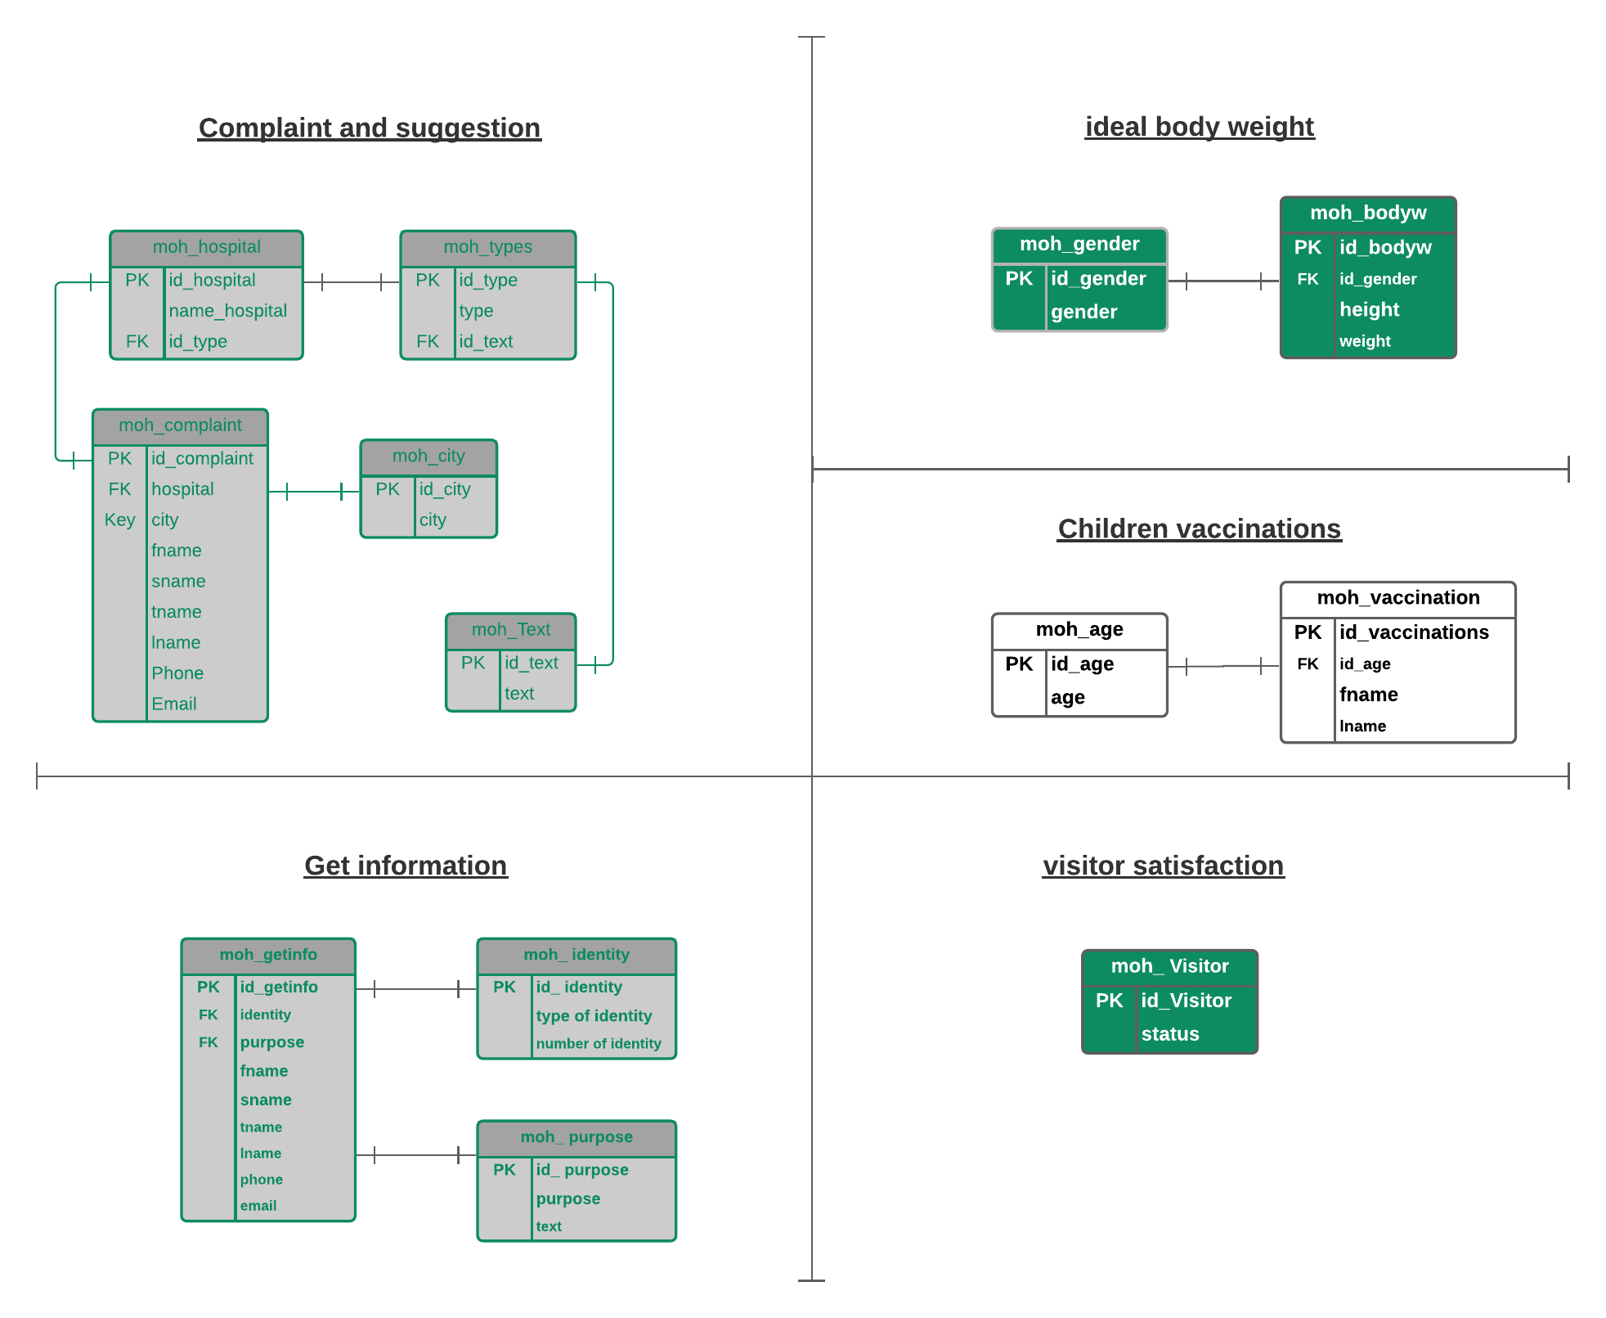

### Figure 31 ERD.

# Development

HTML: Hypertext Markup Language (HTML) is the standard [markup language](https://en.wikipedia.org/wiki/Markup_language) for documents designed to be displayed in a [web browser](https://en.wikipedia.org/wiki/Web_browser)

CSS:Cascading Style Sheets (CSS) is a [style sheet language](https://en.wikipedia.org/wiki/Style_sheet_language) used for describing the [presentation](https://en.wikipedia.org/wiki/Presentation_semantics) of a document written in a [markup language](https://en.wikipedia.org/wiki/Markup_language) such as [HTML](https://en.wikipedia.org/wiki/HTML).

JavaScript: is a programming language commonly used in web development. It was originally developed by Netscape as a means to add dynamic and interactive elements to websites.

Bootstrap framework:is a [free and open-source](https://en.wikipedia.org/wiki/Free_and_open-source) [CSS framework](https://en.wikipedia.org/wiki/CSS_framework) directed at responsive, [mobile-first](https://en.wikipedia.org/wiki/Responsive_web_design#Mobile_first,_unobtrusive_JavaScript,_and_progressive_enhancement) [front-end web development](https://en.wikipedia.org/wiki/Front-end_web_development). It contains [CSS](https://en.wikipedia.org/wiki/CSS)- and (optionally) [JavaScript](https://en.wikipedia.org/wiki/JavaScript)-based design templates for [typography](https://en.wikipedia.org/wiki/Web_design#Typography), [forms](https://en.wikipedia.org/wiki/Form_(HTML)), [buttons](https://en.wikipedia.org/wiki/Button_(computing)#HTML), [navigation](https://en.wikipedia.org/wiki/Web_navigation#Local_website_navigation), and other interface components.

PHP: is a [general-purpose](https://en.wikipedia.org/wiki/General-purpose_programming_language) [scripting language](https://en.wikipedia.org/wiki/Scripting_language) especially suited to [web development](https://en.wikipedia.org/wiki/Web_development). It was originally created by Danish-Canadian [programmer](https://en.wikipedia.org/wiki/Programmer) [Rasmus Lerdorf](https://en.wikipedia.org/wiki/Rasmus_Lerdorf" \o "Rasmus Lerdorf) in 1994; the PHP [reference implementation](https://en.wikipedia.org/wiki/Reference_implementation) is now produced by The PHP Group.

MySQL: is an [open-source](https://en.wikipedia.org/wiki/Open-source_software) [relational database management system](https://en.wikipedia.org/wiki/Relational_database_management_system) (RDBMS).[[5]](https://en.wikipedia.org/wiki/MySQL#cite_note-whatismysql-5)[[6]](https://en.wikipedia.org/wiki/MySQL#cite_note-6) Its name is a combination of "My", the name of co-founder [Michael Widenius](https://en.wikipedia.org/wiki/Michael_Widenius)'s daughter, and "[SQL](https://en.wikipedia.org/wiki/SQL)", the abbreviation for [Structured Query Language](https://en.wikipedia.org/wiki/Structured_Query_Language).

# Testing

## Test Cases

|  |
| --- |
|  |

I considered the priority of the test case as P1-P5 and P1 is the lowest priority and P5 highest priority.

TC: Test case. N/a: not available. P: priority.

### Figure 32 Test Cases.

|  |  |  |  |  |  |  |
| --- | --- | --- | --- | --- | --- | --- |
| **TC-ID** | **TC-Feature** | **TC-Description** | **Priority** | **Steps to execute** | **Test Data Input** | **Expected Result** |
| TC-1 | Required fields | Check the required fields by not filling any data | P5 | 1. Do not enter any value in the field. 2. Click on the Register button. | N/a | It should show an alert on mandatory fields. |
| TC-2 | Required fields | Check user should Register by filling all the required fields | P4 | 1. Enter valid values in the required fields.  2. Click the Register button. | N/a | 1. Users should be registered successfully.  2. A successful registration message should show. |
| TC-3 | Email validation | • Check the Email text field that has an Email address without @ symbol. | P4 | 1. Enter Invalid Emails  2. Click on the Register Button. | Ruaagmail.com | It should show the validation message for valid email |
| TC-4 | Email validation | Check all the valid emails | P4 | 1. Enter valid Emails  2. Click on the Register Button. | Ruaa@gmail.com | It should not show any validation message |
| TC-5 | Phone Number validation | Check the phone number when enter value less than 10 | P4 | 1. Enter valid phone number when value less than 10  2.Click on Register button | 0790000 | It should show the validation message for valid phone number |
| TC-6 | Phone Number validation | Check the phone number when enter value equal 10 | P4 | 1. Enter valid phone number when value equal 10  2.Click on Register button | 0790000000 | It should not show any validation message |
| TC-7 | Weight validation | Check the weight when enter value less than 1 | P3 | 1. Enter valid weight when value less than 1  2.Click on Register button | 0  -1 | It should show the validation message for valid weight |
| TC-8 | Weight validation | Check the weight when enter value more than 0 | P3 | 1. Enter valid weight when value more than 0  2.Click on Register button | 50 | It should not show any validation message |
| TC-9 | Height validation | Check the Height when enter value less than 1 | P3 | 1. Enter valid Height when value less than 1  2.Click on Register button | 0  -1 | It should show the validation message for valid Height |
| TC-10 | Height validation | Check the height when enter value more than 0 | P3 | 1. Enter valid Height when value more than 0  2.Click on Register button | 50 | It should not show any validation message |

# Deployment

## This project has been uploaded to my GitHub repository.

(https://github.com/RuaaAbuShraikh/HTU)

# Source Code

<h2> مطاعـيم   <span id="gray"> الأطفال </span></h2>

<div class="weight">

<div class="container d-flex justify-content-center">

  <div class="row my-2 mx-2">

      <div class="col-md-6">

            <form id="form3" method="post" action="baby.php">

              <div class="form-group pt-2 pl-1"> <label for="babyname">الاسم  : </label>

                <input type="text" class="form-control" id="babyname" name="babyname" required> </div>

                 <label for="" style="float: right; font-size: 20px; padding-left: 5px;color: #828282; ">العمر بالأشهر :</label>

                 <select name="age">

                 <option value="1">1</option>

                 <option value="2">2</option>

                 <option value="3">3</option>

………………………

                 <option value="18">18</option>

             </select>

                 <div class="row">

                  <div class="col-md-3 offset-md-9">

                    <input type="submit"  name="submit" class="btn " >

                  </div>

              </div>

          </form>

      </div>

      <div class="col-md-6"> <img src="images/baby.jpg" alt="IMG"> </div>

      <h5 style="margin-top: 40px;"> مفهوم التطعيم      </h5>

      <ul style="text-align: right;">

<li>  هو عبارة عن حقنة تحتوي على كائنات مجهرية دقيقة (بكتيريا أو فيروس) لها دور في حدوث أمراض معينة. تُعالج هذه الميكروبات في المختبر لتصبح غير ضارة بالإنسان، وتهدف إلى تطوير قدرة الجهاز المناعي على الاستجابة السريعة للإصابة بتلك الميكروبات، فبعد حقن الجسم بهذه اللقاحات (المطاعيم) يتم تحفيز جهاز المناعة على تكوين أجسام مضادة لمكافحة هذه الكائنات، وأيضا يتم تفعيل آلية خلايا الذاكرة المناعية، فتصبح قادرة على التعرف السريع والاستجابة الفاعلة عند حدوث مواجهة ثانية بين جهاز المناعة والكائنات المجهرية نفسها، أي أن جسم طفلك يبدأ بتعلم كيفية حماية نفسه.</li> </ul>

      <?php

include './config.php';

if(isset($_POST['submit'])) {

    $age = isset($_POST['age']) ? $_POST['age']: 0;

    $babyname = $_POST['babyname'];

    $babylname = $_POST['babylname'];

echo " اسم الطفل  " . $babyname . "   ". $babylname.  "<br>" ;

echo " عمر الطفل  ". $age  . "شهر" ;

echo "<br>";

    switch ($age) {

        case 1:

            echo "مطعوم التدرن أو السل (BCG)";

        break;

        case 3:

            echo "يعطى الجرعة الأولى من مطعوم شلل الأطفال (IPV) والمطعوم الخماسي الذي يتكون من: المطعوم الثلاثي (DPT)، (الدفتيريا والسعال الديكي والكزاز)، مطعوم المستدمية النزلية نوع (ب)، (HiB) المسبب لمرض التهاب السحايا البكتيرية لدى الأطفال وخصوصا دون السنة من العمر، مطعوم التهاب الكبد نوع “ب”(HBV).";

        break;

……………..

     default :

        echo " لا يوجد مطاعيم لهذا الشهر" ;

    }

 $data= $mysqli->query("INSERT INTO `htu`.`formt3` (`babyname`, `babylname` ,`age`  )

   VALUES ('$_POST[babyname]', '$_POST[babylname]' , '$_POST[age]'    );  ");

# Conclusion

The human is our most precious possession. In the beginning, I chose the Ministry of Health, then created a Sitemap and wrote content for each page, and after that I made a wireframe, then a mockup.  
I started coding to create pages using (HTML5, CSS3, JavaScript and bootstrap framework) for front end and (PHP) for back end.

 I have programmed three electronic services for the Ministry of Health; also it contains information about the ministry, news, health awareness and regulations.

The goals of this web application are to improve my technical skills and apply what I have learned in this training. I hope my web application exceeds your expectations. In the future, I will develop my web application to make it better.

# References

[1] <https://en.wikipedia.org/wiki/HTML>

[2] <https://en.wikipedia.org/wiki/CSS>

[3] https://techterms.com/definition/javascript

[4] https://en.wikipedia.org/wiki/Bootstrap_(front-end_framework)

[5] https://en.wikipedia.org/wiki/PHP

[6] https://en.wikipedia.org/wiki/MySQL****

[7] https://www.pexels.com/